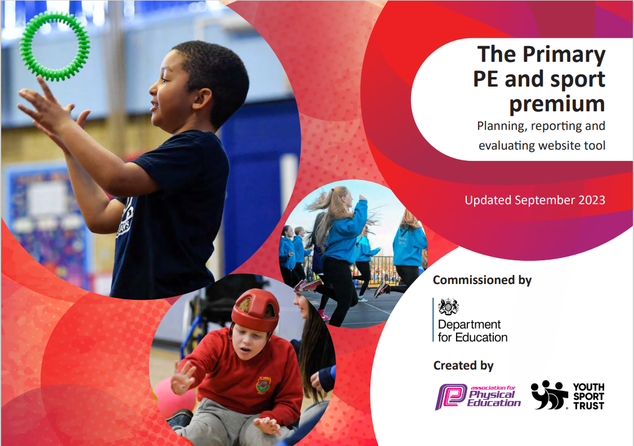
The Mill Academy
2025-2026

Support for review and reflection - considering the 5 key indicators from DfE, what development needs are a priority for your setting and your students now and why? Use the space below to reflect on previous spend, identify current need and priorities for the future.
Key achievements to date: | Areas for further improvement and baseline evidence of need:
Children are able to take part in a wide range of sporting clubs.  Children encouraged to take part in competitive sports.  Clubs provided for both KS1 and KS2 children of all abilities.  Sporting activities outside of school can be celebrated.  Children were given the opportunity in upper KS2 to take part in residential. Children to take part in outdoor adventurous activities.  Children gain new skills and are confident to try new sports. Introducing a whole school tracking system to detail inter/intra activities children have taken part in.  Purchased new PE equipment to improve the quality of children’s learning and development.  Provide children with a wider variety of sports and activities throughout the academic year via external providers | Further develop quality of teaching & learning of Physical education through mentoring & coaching plus development of a PE curriculum team.  Develop a broader range of extra-curricular activities.  Develop links with local schools who are members of the local Sports Pyramid. A full program of inter schools competitions are planned including, cross country, netball, hockey, boccia and basketball.  Develop healthy lifestyle choice initiatives through walk/scooter or bike to school, road safety, healthy breakfast club options.  We pledge to provide inclusive, accessible sporting opportunities and experiences that support our pupils’ personal development—enabling them to grow as self-aware, empathetic, and responsible individuals.  Through a wide range of adapted and mixed-ability activities, we aim to ensure every student, regardless of gender, ability, identity, neurodiversity, or background, can participate fully and feel valued.  Year 4 pupils learn to swim through an annual programme of swimming lessons.  Sports coaches incorporate daily exercise sessions during breakfast club, and lunchtime.  Weekly sports clubs are available after school to support our extra-curricular provision.
Meeting national curriculum requirements for swimming and water safety |  | Please complete all of the below:

What percentage of your current Year 6 cohort swim competently, confidently and proficiently over a distance of at least 25 metres?  N.B. Even though your children may swim in another year please report on their attainment on leaving primary school. | 47%
What percentage of your current Year 6 cohort use a range of strokes effectively [for example, front crawl, backstroke and breaststroke]? | 60%
What percentage of your current Year 6 cohort perform safe self-rescue in different water-based situations? | 30%
Schools can choose to use the Primary PE and Sport Premium to provide additional provision for swimming but this must be for activity over and above the national curriculum requirements. Have you used it in this way? | Yes



Academic Year: 2025/26
Total fund allocated: £17,800
Key indicator 1: The engagement of all pupils in regular physical activity – Chief Medical Officer guidelines recommend that primary school
children undertake at least 30 minutes of physical activity a day in school.
Date Updated: September 2025

Percentage of total allocation: 34%

School focus with clarity on intended
impact on pupils:
Daily Mile conducted in each class within own timetable.

Pupils are offered a range of after- school clubs.

KS2 Sports leaders in school with be trained via external provider to facilitate lunch time activities
Lunchtime staff will monitor this.
Actions to achieve:

Pupils to take part in daily exercise: daily mile (run/walk). Stickers and prizes awarded

After school club staff to provide varied after- school clubs in sports and PE skills (football, running, dodgeball, etc.)
Contact local sports clubs to provide taster sessions for a range of different sports.

lunchtime staff to work alongside sports leaders to ensure a wide range of sports are being led.
Funding allocated:
N/A free

Staffing cost: 2506

£500
Evidence and impact:

Increased levels of physical activity each day.

Registers kept of children who are participating in lunch time sports to ensure sport/PE is inclusive for all.
Focus on key pupil groups (girls/boys/PP/Non-PP/EAL/SEND)

Resources ordered are used to deliver high-quality lessons in PE. Children have access to a range of sports and understand basic skills and rules to be able to engage in competitions across the year.
Sustainability and suggested next steps:
Children to have increased levels of fitness and passion for physical activity. Increased levels of concentration in class.

Promote leadership and communication skills amongst children. All children in school have the opportunity to participate in physical activity each day in school.

Sports leaders able to show confidence in using sporting equipment and leading sports. New sports leaders to be trained each year.

All pupils offered access to all clubs but range of sports to increase year on year. Signposts to outside agency clubs available and highlighted to all pupils.

After-school club registers to highlight children who attend more than one club. Also, percentage of pupils groups identified. Pupil Premium groups to be

School to promote ‘Walk to school week’ 2025.  Children to partake in sporting endeavours in an inclusive and engaging environment using high-quality resources including balance bikes for EYFS pupils. | Encourage pupils to participate in walk to school week. Promote in classes.  Audit of resources/staff survey at the start of the academic school year and each half term by PE lead to ensure high quality resources are readily available for staff to deliver PE sessions and after school clubs. | £500  £2500 |  | highlighted and encouraged to attend. Prizes awarded through celebration assembly  Next steps: Pupil voice conducted to find out which sports children would like to compete in.
Key indicator 2: The profile of PESSPA being raised across the school as a tool for whole school improvement |  |  |  | Percentage of total allocation:
 |  |  |  | 3%
School focus with clarity on intended  impact on pupils: | Actions to achieve: | Funding allocated: | Evidence and impact: | Sustainability and suggested next steps:
hildren to be exposed to a wide range of sporting activities at playtime and lunchtimes.  Sports to be lead by sport’s leaders at lunchtimes.  Invite local community sports group into school to run assemblies and workshops eg Barnsley FC | Organise inter-school competitions at lunchtimes.  Ensure sports leaders are trained and confident in leading sports.  Raise awareness of sporting excellence and create memories. | N/A free  £500  N/A free | Photographs and registers kept of children who are participating in competitive sports.  Focus on key pupil groups (girls/boys/PP/Non-PP/EAL/SEND)  Higher percentage of children to participate in physical activity during playtimes and lunchtimes. Improved sportsmanship and social skills.  Raising aspirations and greater understanding of diversity in life and sport | Sport’s leaders from previous school year to continue lead sports and new sports leaders to continue into new academic year.  Next steps: Monitor percentage of pupil groups who have attended sporting competitions (girls/boys/PP/Non-PP/EAL/SEND) and invite children to participate in further events as appropriate.

Key indicator 3: Increased confidence, knowledge and skills of all staff in teaching PE and sport |  |  |  | Percentage of total allocation:
 |  |  |  | 0%
School focus with clarity on intended  impact on pupils: | Actions to achieve: | Funding allocated: | Evidence and impact: | Sustainability and suggested next steps:
Teachers to provide high-quality lessons which teach progression of skills in a range of sports. | Staff CPD from PE team to ensure all staff aware of how to use equipment and rules of varied games expected to be taught, prior to teaching sports. | N/A Free | Staff able to teach high-quality PE using quality resources which is linked to progressive skills and assessment activities. | Children take part in a range of sports in and out of school.
 | Staff CPD from external provider to develop staff knowledge and skill set to support in delivering high-quality PE lesson to pupils linked to specifics of the PE curriculum. | N/A Free | All pupils assessed regularly in PE and links to future planning created based on the lack of skills in each class/pupil. | Teaching staff are confident and clear about how to teach PE and sports across the curriculum.  They can also confidently assess and plan for progression within each sport.
 |  |  |  | Resources are available to teach children key skills in order to partake in competitions across the region against local and Barnsley wide schools.
Key indicator 4: Broader experience of a range of sports and activities offered to all pupils |  |  |  | Percentage of total allocation:
 |  |  |  | 25%
School focus with clarity on intended  impact on pupils: | Actions to achieve: | Funding allocated: | Evidence and impact: | Sustainability and suggested next steps:

Swimming lessons as standard in Year 4.  Bikeability programme delivered to Year 5 Cohort. | Swimming lessons purchased and coach travel. Aim for 70% competent swimmers in the year 4 cohort  All pupils who show an interest in dance to be encouraged to attend this club. | £4470  N/A free. | There is an increase in the number of children who can swim 25m by the end of the swimming block.  ALL children accessing professional training and road safety learning to cycle and be safe by the road. An increase in the number of children who can ride a bike. | Children will gain knowledge of water safety which can be applied in a variety of situations and able to swim confidently.  Children able to cycle to school every day and children are learning to ride a bike at an early age.
Key indicator 5: Increased participation in competitive sport |  |  |  | Percentage of total allocation:
 |  |  |  | 36%
School focus with clarity on intended  impact on pupils: | Actions to achieve: | Funding allocated: | Evidence and impact: | Sustainability and suggested next steps:
Children to attend sports competitions in a range of sports across the locality pyramid/network.  All children to be given opportunity to showcase talents in all sports across school. (FS-Y6)  HCAT across the Trust competitions for all pupils. Pay for coach hire ensuring those from disadvantaged backgrounds are included | Extra coach travel provided to ensure no pupils miss out.  In-house competitions arranged for all pupils in key stages to compete against one another. (Fs – Y1/2; Y3-Y4; Y5-Y6) Sports leaders to set up competitions across school at breaks.  Meet with PE leads across the trust to create an events calendar – one competition per term. | £3,400 Coach travel to events  £2000; coach travel to off site venue.  £930 subscription to Pyramid Sports Programme. | Competitive sporting competitions promote teamwork and wider opportunities.  Photographs/ videos of pupils taking part in in-house competitions.  Wider links with other schools in the local area to increase participation of sports. | Children to attend competition across schools – continue to next academic year. Funding allocated for coaches. Staff will be able to take groups within class and key stage. Gather pupil voice on the sporting provision that pupils would like to participate in throughout the year to ensure it is tailored to children’s interests and talents.  Next steps: Find out which sports children would like to compete in throughout the year to ensure interests of children are always being considered.

