The Mill Academy
Homework Policy
September 2025
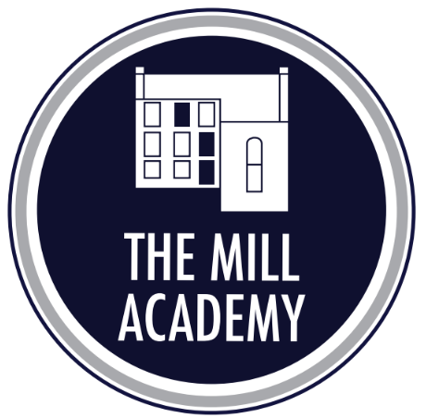

Inspire, Achieve & Grow
As a school, we are dedicated to helping you learn to be kind, confidence, and resilience through the opportunities and experiences we provide.
We will support you to work as a team, think independently, and celebrate your achievements—giving you the tools to aim high and feel proud.
At The Mill Academy, we believe homework consolidates and reinforces skills and understanding in numeracy, literacy and other curriculum areas, helps raise the level of achievement of individual pupils, provides opportunities for parents and children to work together and, thereby, fostering an effective partnership between home and school.

We value the support of parents/carers and we believe that this policy will be successful if there is a strong partnership between home and school.

We recognise that all children need leisure time and hope that our policy reflects a balance so children can extend and consolidate their learning with parental support while still allowing ‘down time.

Homework Structure
In Foundation stage, children have weekly reading books, key words to read and spell and links to explore number and phonics through their theme work.
In Years 1 to 6 children have:
- Regular home reading.
- Use of Times Table Rockstars to practise times tables. Year 3 and Year 4 have targeted times tables to practise based on their heat maps.
- Phonics homework in EYFS and KS1 (and for some pupils who still need this in Key Stage 2)
- Weekly spellings to learn and spelling test in Years 2 – Year 6 (these are from our Read, Write, Inc spelling)
The expectations are that these are completed weekly and are checked my class adults every Friday.
Seesaw
Seesaw is the school’s platform to support with home learning. In addition to the weekly expectations, there may be times when class teachers also use Seesaw as the platform to upload homework tasks for children complete. This will be communicated to the children so they are clear on any tasks uploaded onto Seesaw and completion deadlines.
