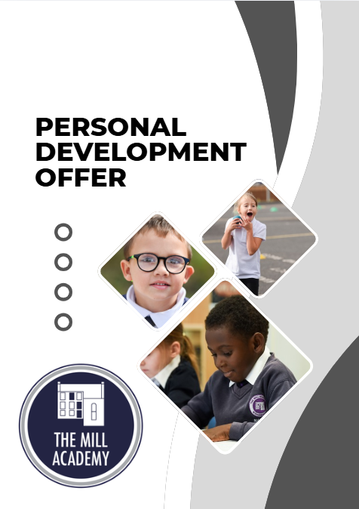

CONTENTS

Introduction P3
Vision; Core Values & Character Traits P4
Pastoral Care, Wellbeing & Mental Health P6
Curriculum P8
Enrichment P10
Pupil Leadership P24
Assemblies P25
PSHE Workshops P26

Introduction

At The Mill Academy, our Personal Development Offer lies at the heart of our commitment to nurturing well-rounded, confident and compassionate individuals who are ready to thrive both within school and beyond. We recognise that education extends far beyond academic achievement; it is about developing character, fostering resilience, promoting wellbeing and equipping pupils with the knowledge, skills and values they need to lead safe, healthy and successful lives.
Our provision is intentionally designed to ensure that every child develops personally, socially, emotionally and morally, alongside achieving academic success. Personal development is not an isolated aspect of school life; it is woven through our curriculum, enrichment programme, pastoral systems, leadership opportunities, community engagement and daily interactions.
We hold high aspirations and ambitions for every pupil. We are committed to nurturing confident, respectful and resilient learners who demonstrate kindness, integrity and responsibility. Through high-quality experiences and strong pastoral support, we prepare children to make positive contributions to their communities and become informed, active citizens in an increasingly diverse and ever-changing world.
Our inclusive approach ensures that all pupils, regardless of background, need or starting point, are supported to flourish. We provide a safe, nurturing and welcoming environment where children feel valued, listened to and empowered to succeed.
We are committed to ensuring that every child:
- Develops confidence, independence and resilience.
- Understands how to keep themselves physically, emotionally and digitally safe.
- Builds positive relationships based on kindness, respect and empathy.
- Develops strong mental health and emotional wellbeing.
- Appreciates diversity and respects differences within modern Britain.
- Understands their rights and responsibilities as citizens.
- Contributes positively to school life and the wider community.
- Discovers and develops individual talents, interests and aspirations.
- Is prepared for the next stage of education and future life opportunities.
Our Personal Development Offer is underpinned by:
- Our School Vision; Values & Character Traits
- Fundamental British Values
- Equality, Diversity and Inclusion
- Safeguarding and Wellbeing
- High Expectations for All
These principles are embedded throughout all aspects of school life and form the foundation of our pastoral culture.
School Vision: As a school, we are dedicated to helping you learn to be kind, confidence, and resilience through the opportunities and experiences we provide. We will support you to work as a team, think independently, and celebrate your achievements—giving you the tools to aim high and feel proud.

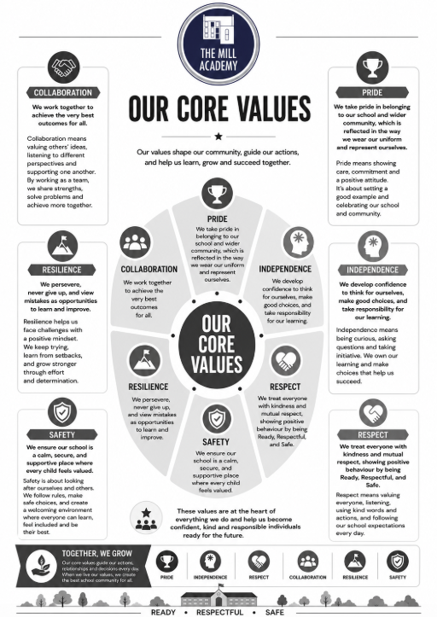

We are dedicated to providing all pupils with expertly planned high-quality experiences that support the development of essential character traits. Through our enrichment offer, children are encouraged to become respectful, resilient, hardworking and ambitious individuals.

These experiences are intentionally designed to:

- Build aspiration and ambition
- Promote tolerance, respect and understanding
- Develop resilience and independence
- Broaden pupils’ horizons and cultural awareness
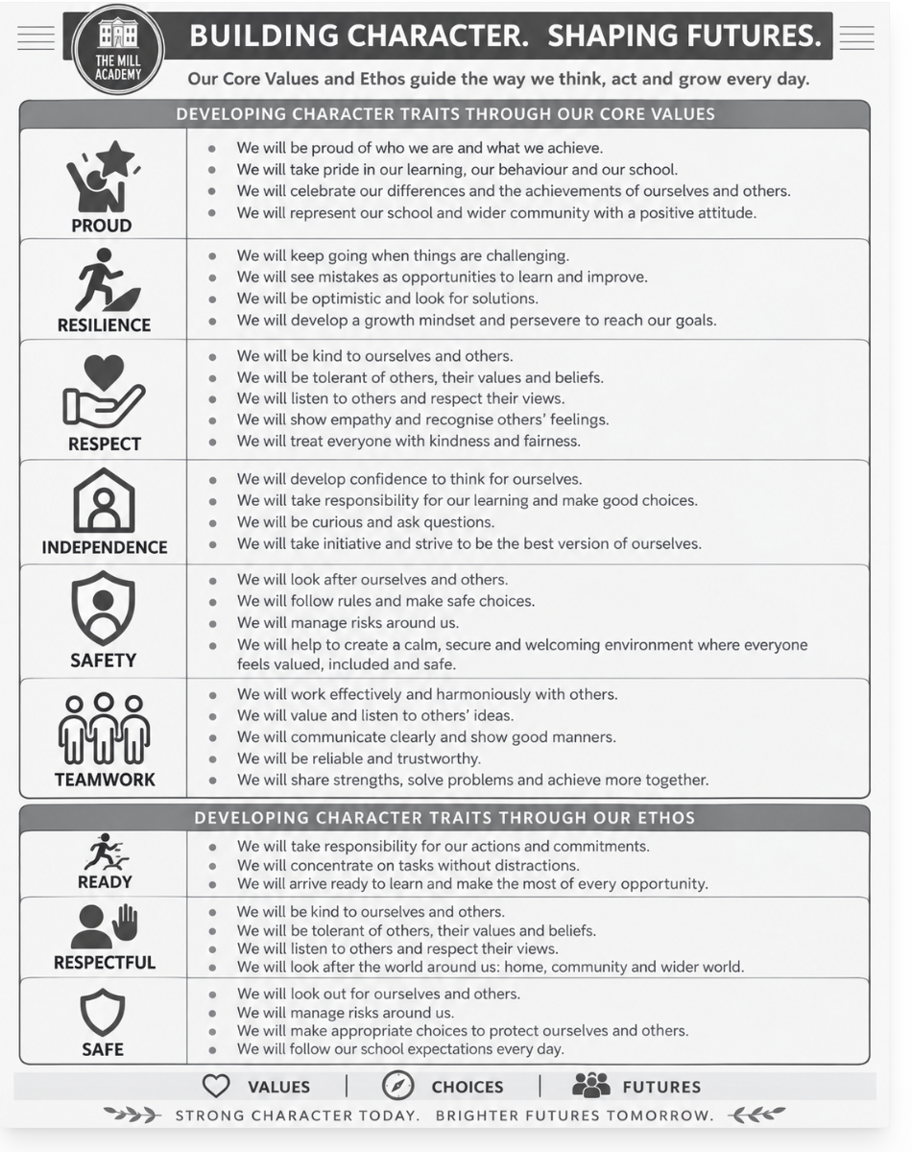

By embedding enrichment throughout our curriculum and wider school life, we ensure that every child is equipped not only to succeed academically, but also to thrive as a confident, compassionate and active citizen who is ready to make a meaningful impact on society.

Pastoral Care, Wellbeing & Mental Health

At The Mill Academy, the wellbeing of every child is at the heart of everything we do. We recognise that children learn best when they feel safe, valued, supported and connected, and we are committed to creating a nurturing environment where every pupil can thrive both emotionally and academically.
Our pastoral care provision is built upon strong relationships, early intervention and a culture of belonging. We ensure that every child is known, understood and supported by caring adults who take the time to listen, guide and champion their individual needs. Through our dedicated pastoral team and wider staff, we provide a strong network of support that helps pupils develop confidence, self-esteem and emotional security.
We understand the importance of promoting positive mental health and emotional wellbeing from an early age. Through a combination of proactive support, targeted interventions and a preventative approach, we help pupils develop the skills needed to understand and manage their emotions, build healthy relationships and respond positively to life's challenges. Opportunities for reflection, discussion and emotional literacy are woven throughout school life, ensuring that children feel confident in expressing concerns and seeking help when needed. Interventions such as Motional, ELSA, counselling and nurture support pupils’ well-being in school.
We strive to ensure that every child feels included, respected and empowered. We promote resilience, independence and self-awareness through daily interactions, curriculum experiences and dedicated wellbeing support. Pupils are encouraged to develop coping strategies, perseverance and a positive sense of self, enabling them to navigate challenges successfully and build strong foundations for future success.
Our pastoral offer includes trusted adults for every child, nurture and wellbeing interventions, mental health awareness programmes, opportunities to share worries and concerns, and timely access to specialist external support where appropriate. We place a strong emphasis on identifying needs early and working collaboratively with families and external agencies to secure the best possible outcomes for our pupils.
Through our comprehensive pastoral care provision, we aim to develop happy, healthy and emotionally resilient children who feel safe, valued and ready to flourish in school, within their communities and throughout their lives.

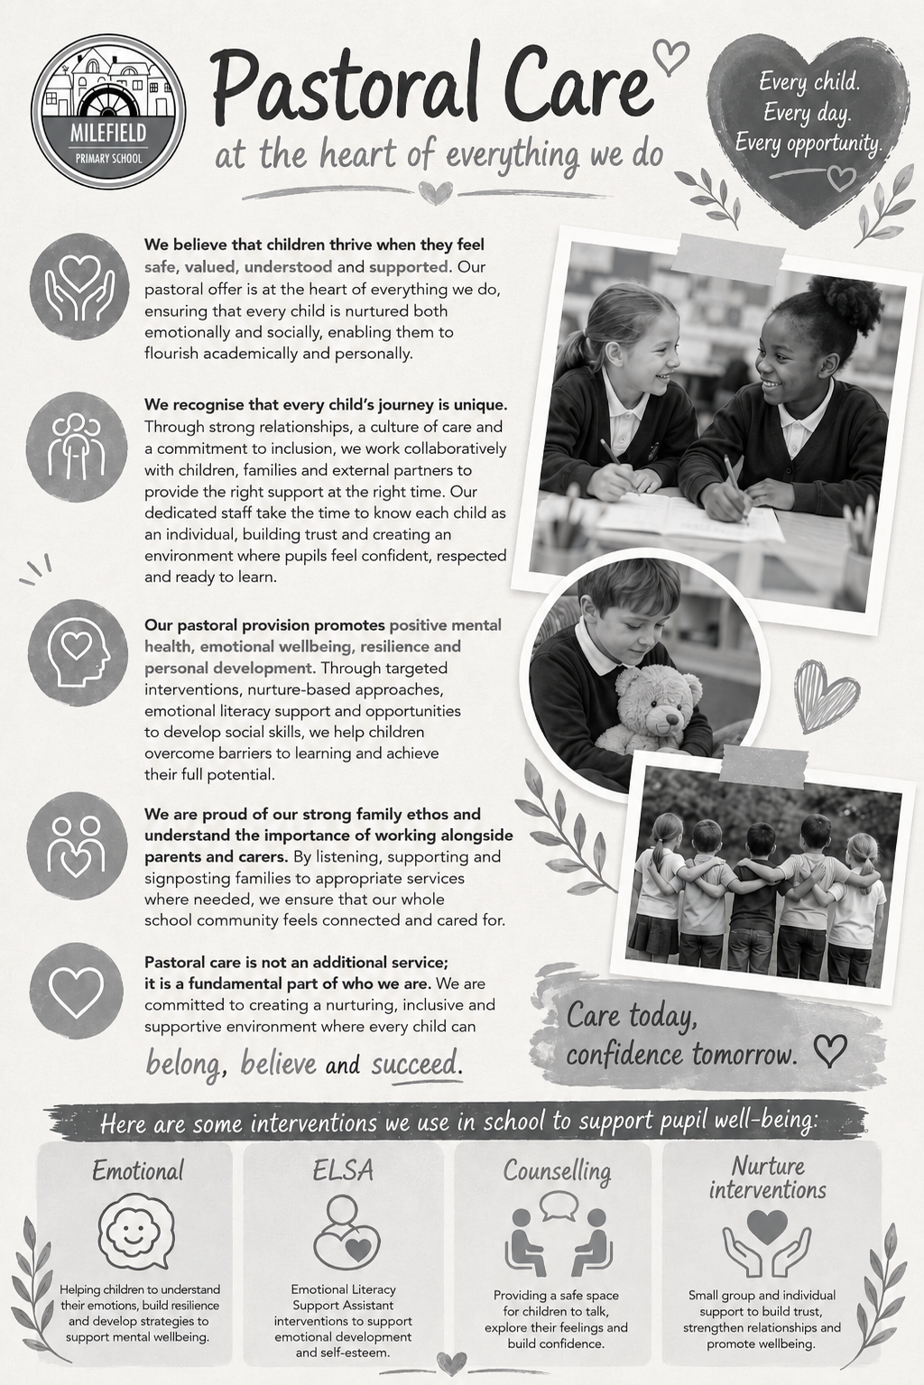
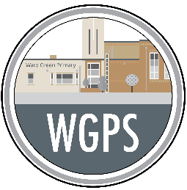
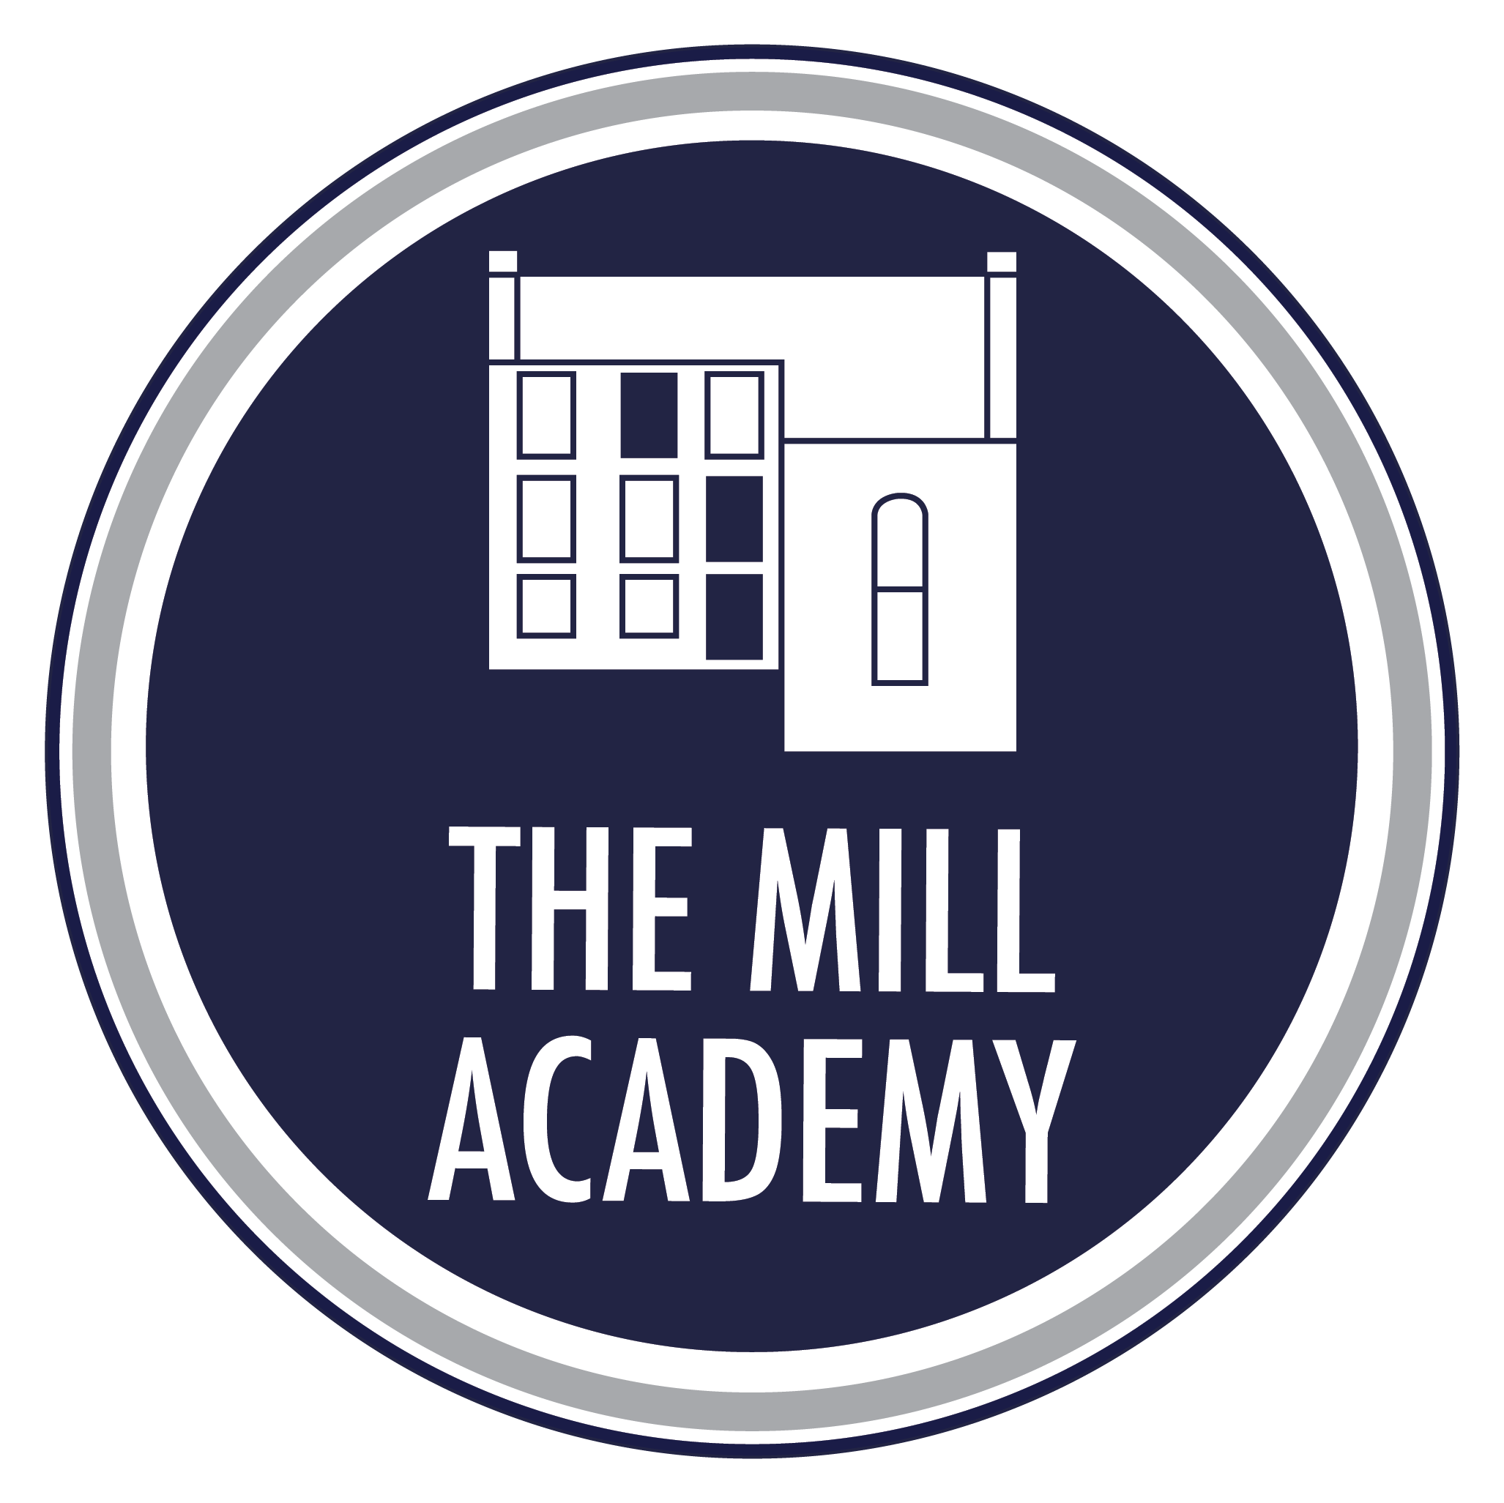

Curriculum

Our Personal Development Curriculum is carefully designed to equip pupils with the knowledge, understanding, skills and values they need to thrive in modern Britain and beyond. Our curriculum goes beyond academic learning to ensure pupils develop the confidence, character, resilience and understanding required to become safe, healthy, responsible and active members of society.
The curriculum is delivered through a carefully sequenced programme of Personal, Social, Health and Economic Education (PSHE), Relationships, Sex and Health Education (RSHE), assemblies, enrichment experiences and cross-curricular learning opportunities. This enables pupils to progressively develop the knowledge and behaviours needed to make informed choices, build positive relationships and navigate the opportunities and challenges they may encounter throughout their lives.
Through our curriculum, pupils develop an age-appropriate understanding of physical and mental health, healthy lifestyles, emotional wellbeing, relationships and friendships, respectful behaviour, personal boundaries, consent, online safety and community safety. They learn how to recognise risks, seek support when needed and make decisions that promote their wellbeing and the wellbeing of others.
Safeguarding is embedded throughout our curriculum and is viewed as a fundamental aspect of personal development. Through a proactive and preventative approach, pupils learn how to stay safe both online and offline, recognise unhealthy or unsafe situations, manage peer influence, identify risks within their community and understand how and when to seek help. Our contextual safeguarding approach ensures pupils are equipped with the knowledge and confidence to make safe and responsible choices in a rapidly changing world.
Our curriculum actively promotes the Fundamental British Values of democracy, the rule of law, individual liberty, mutual respect and tolerance. Through meaningful learning experiences and opportunities to participate in school life, pupils gain an understanding of their rights and responsibilities, develop informed opinions and learn to engage respectfully with different viewpoints. We encourage children to become active citizens who understand their role in contributing positively to both their local community and wider society.
Equality, diversity and inclusion are integral to our curriculum. We celebrate the richness of different cultures, faiths, backgrounds and experiences and ensure that pupils develop respect for others and an appreciation of the diverse society in which they live. Children are taught to challenge stereotypes, recognise discrimination and value inclusion and belonging. Through age-appropriate learning about protected characteristics and diversity, pupils develop empathy, understanding and respect for difference, preparing them to live and work in an increasingly interconnected world.
We also recognise the importance of developing aspiration and preparing children for future success. Pupils are introduced to a wide range of careers, inspirational role models, employers, community leaders and enterprise experiences. These opportunities broaden horizons, raise aspirations and help children understand the links between learning, future pathways and the world of work. Pupils are encouraged to identify their strengths, talents and interests, fostering ambition, self-belief and a positive outlook towards their future.
Through our comprehensive Personal Development Curriculum, we strive to ensure that every child leaves as a confident, respectful and resilient individual who understands how to keep themselves safe, build positive relationships, embrace diversity and contribute positively to society. Our aim is that all pupils are exceptionally well prepared for the next stage of their education and have the knowledge, character and aspirations needed to flourish throughout their lives.
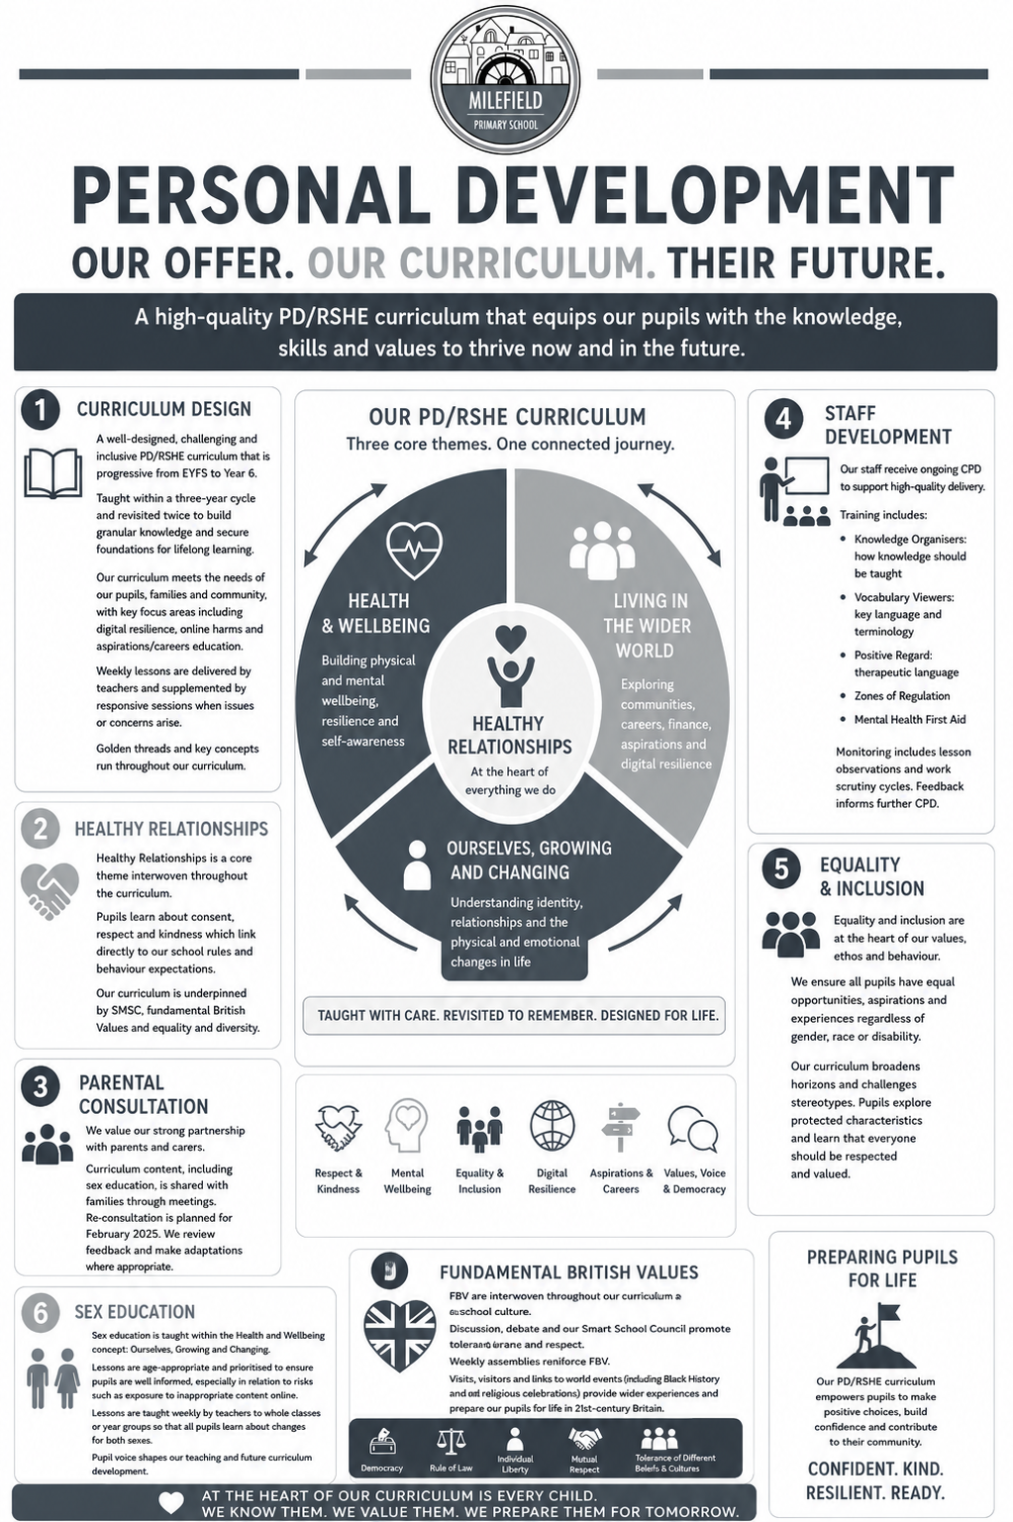
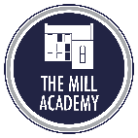

Enrichment

We recognise enrichment as a fundamental component of our curriculum, rather than an optional addition. Our Personal Development and Enrichment offer is deliberately designed to ensure that every pupil, regardless of background or starting point, benefits from a carefully sequenced and ambitious programme of experiences. These opportunities are intended to broaden horizons, develop cultural capital, strengthen character, and prepare children for the opportunities, responsibilities and experiences of later life.

Our offer has been shaped directly through consultation with our pupils and parents, reflecting our commitment to ensuring all children are provided with high-quality experiences and opportunities that build cultural capital and enhance their awareness of the wider world. This collaborative approach ensures that our enrichment offer is both meaningful and responsive to the needs of our school community.

This approach reflects the expectations of the National Curriculum, which requires schools to provide a broad and balanced education that promotes pupils’ spiritual, moral, social, cultural, mental and physical development, while effectively preparing them for adult life.

Our enrichment strategy is closely aligned with the DfE Enrichment Framework for Schools and Colleges. We ensure that enrichment is:

- Strategically planned and coherently sequenced
- Broad and inclusive, offering a wide range of opportunities
- Accessible to all pupils, regardless of circumstance
- Closely connected to curriculum learning, personal development, wellbeing and future aspirations

We recognise that high-quality enrichment plays a vital role in expanding pupils’ experiences beyond their immediate environment, raising aspirations, improving engagement, and fostering a strong sense of belonging—particularly for those pupils who may have limited access to such opportunities outside of school.

At the heart of our approach is a commitment to holistic development. We aim to empower pupils to become self-aware, empathetic and responsible individuals who can make a positive contribution to their community and the wider world. Through a thoughtfully designed programme of experiences, we support pupils in developing a deeper understanding of:

- Our core values
- Fundamental British Values
- Protected characteristics
- The school’s ethos and inclusive culture.

The 5 Enrichment Strands
Enrichment is deliberately planned through five key strands, ensuring pupils build knowledge, confidence, aspiration and social capital progressively from Reception to Year 6:




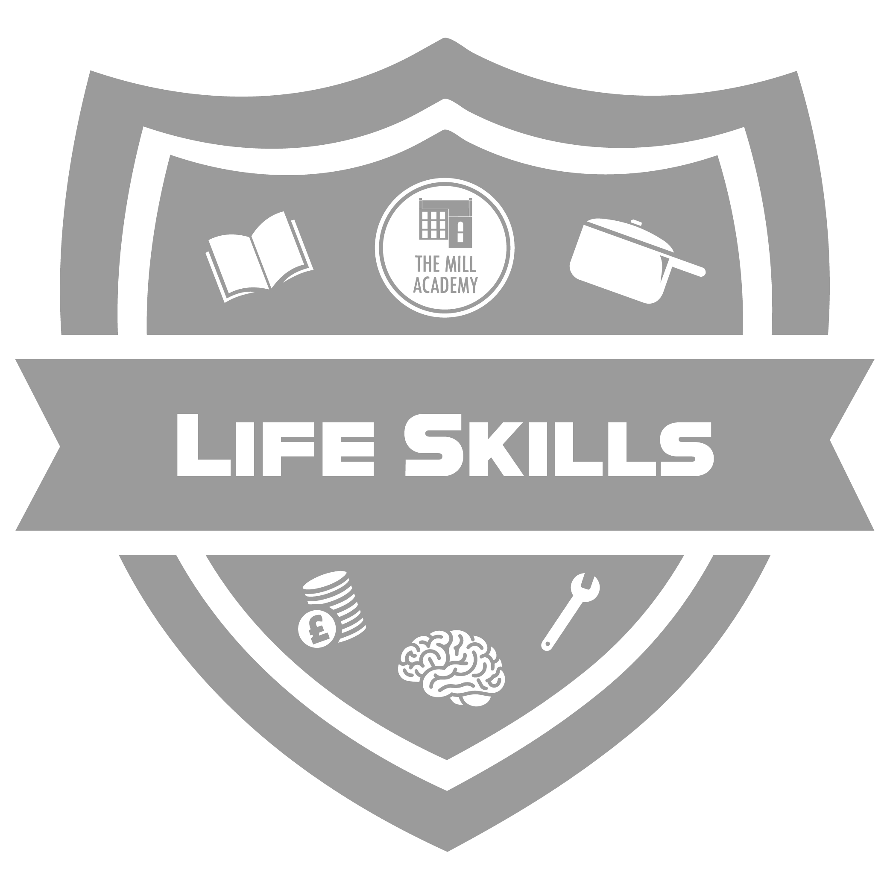
Together, these strands ensure a coherent entitlement that helps children to know more, experience more and become more — not simply through visits or events, but through carefully sequenced opportunity.
Strategic Rationale
The design of the enrichment offer is underpinned by four key principles:
- Children learn best when abstract concepts are rooted in first-hand, memorable experiences.
- The frequency and range of children’s personal experiences support language development, background knowledge and understanding of the world, particularly in the early years.
- Opportunities for cultural, civic and aspirational development must be available to all pupils, not just those who can access them beyond school.
- Enrichment is a progressive curriculum that moves children from familiarity to independence, from participation to contribution, and from local belonging to wider ambition.
This approach is particularly important in relation to educational equity. Many of the experiences included in our offer - such as theatre visits, museums, live sporting events, restaurants, faith visits, residential experiences and travel to London -provide essential cultural reference points and vocabulary that enable pupils to access the taught curriculum more confidently and more fairly. In this sense, enrichment supports curriculum access, personal development and social justice simultaneously.

Impact and Value of the Offer
The enrichment offer has a clear impact beyond the completion of individual visits or events. Through this programme, pupils develop the background knowledge, language, confidence and social understanding that enable them to engage more fully with the taught curriculum and with life beyond school. The programme also helps pupils to develop a stronger sense of identity, belonging and aspiration.
This is fully consistent with evidence cited by the Department for Education that enrichment is associated with improved school belonging, wider engagement and positive educational outcomes.
Importantly, the offer is not accidental or opportunistic. It is planned, progressive and purposeful, with each stage preparing pupils for the next:

Confidence  in the familiar world | Understanding  of society, culture and belief | Readiness  for the next stage of life
This reflects both the school’s vision and national expectations that enrichment should be inclusive, strategically aligned and outcomes focused.

Conclusion
Our offer represents a strong example of enrichment as an entitlement for all pupils. It is rooted in the school’s values, aligned with national expectations, and structured to ensure clear progression from Reception to Year 6. It supports children not only to achieve academically, but also to become curious, respectful, resilient and socially aware young people who are prepared for the next stage of learning and for life in modern Brita


1. Civic Engagement

Building responsibility, confidence and a sense of belonging and community.

Intent
The purpose of the Civic Engagement strand is to ensure that pupils develop a strong sense of belonging, responsibility and active citizenship within their school, local community and the wider world.

Progression across this strand moves children from understanding their role within familiar groups to meaningful participation, leadership, advocacy and social action. Through opportunities such as school councils, community projects, fundraising and discussions about fairness and responsibility, pupils learn to contribute positively, collaborate effectively and value diverse perspectives.

These experiences build confidence, empathy, communication and decision-making skills, while fostering an understanding of democratic values and social responsibility.

This aligns closely with EYFS personal, social and emotional development and with the wider curricular duty to prepare pupils to become informed, responsible and engaged members of society.

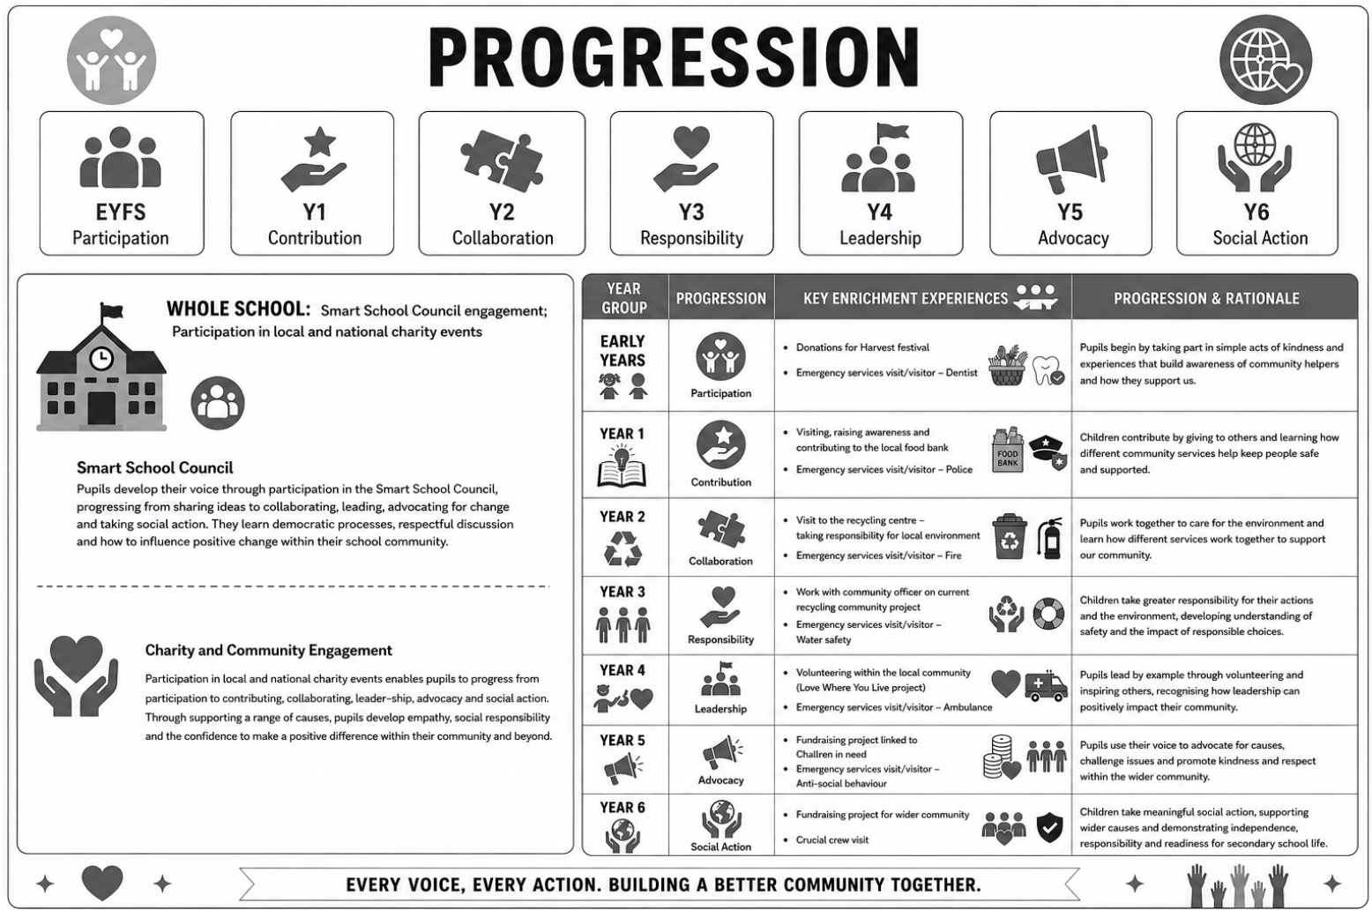

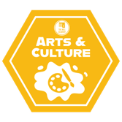
2. Art & Culture

Experiencing culture and live performance as an entitlement; developing awareness and appreciation of diversity, expression and open-mindedness.

Intent

Engaging with art and cultural experiences in school broadens pupils’ understanding of the world and encourages creativity.

Through activities such as visual arts, music, dance, and exploring cultural traditions, children develop confidence in expressing their ideas and emotions.

These experiences also promote curiosity, respect for diversity, and critical thinking. Regular exposure to art and culture supports language development, collaboration, and a deeper connection to their community, helping them to grow as well-rounded and reflective learners.

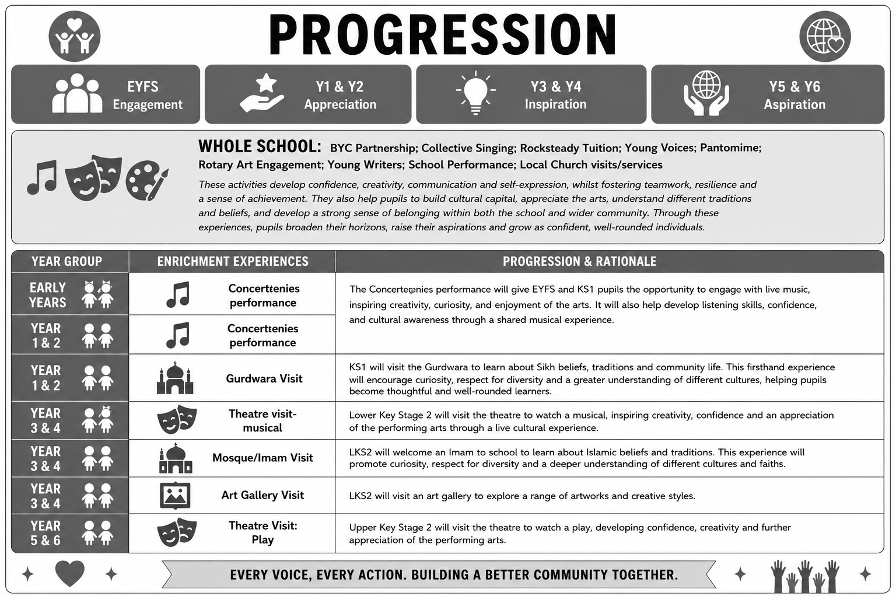


3. Nature, Outdoors & Adventure

Developing curiosity, resilience and confidence through exploration, challenge and connection with nature.

Intent
Learning through nature, outdoor activities, and adventure helps primary pupils develop confidence, resilience, and a sense of curiosity about the world around them.

Experiences such as exploring green spaces, participating in outdoor challenges, and engaging in hands-on learning encourage teamwork, problem-solving, and independence.

Being outdoors also supports physical health and well-being, while providing opportunities for creativity and reflection. For young pupils, these experiences foster a deeper connection to their environment and help them grow as active, engaged, and confident learners.

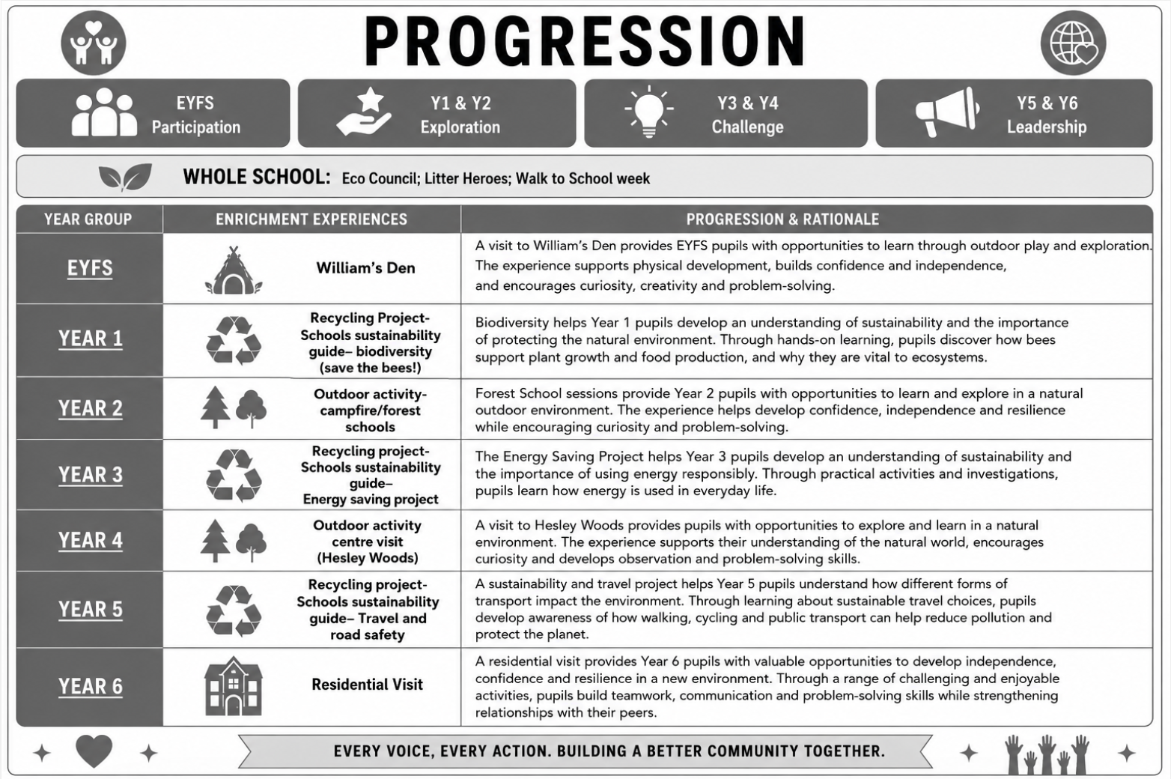


4. Sports & Physical Activity

Experiencing a range of sports and physical activities as an entitlement; developing confidence, resilience, teamwork and a positive attitude towards health and wellbeing.

Intent
Participating in sport and physical activity helps primary pupils build healthy habits while developing confidence and self-discipline.

Through activities such as team games, fitness exercises, and active play, children improve their physical health, coordination, and motor skills.

These experiences also encourage teamwork, communication, and resilience, as pupils learn to handle both success and challenge. Regular physical activity supports concentration and well-being, helping pupils to stay engaged in their learning and grow into active, positive members of their school community

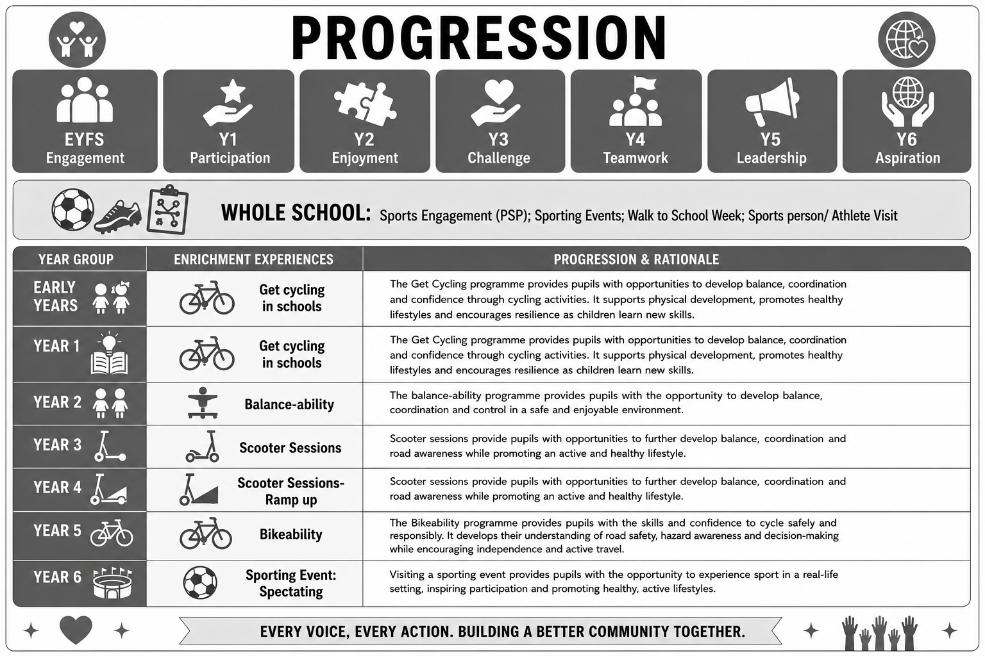

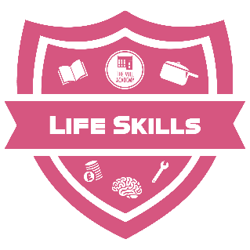
5. Developing Wider Life & Future Skills

Building confidence, resilience, independence and adaptability through real-world experiences, problem-solving and teamwork.

Intent

Developing wider life and future skills helps primary pupils build the foundations they need for success both in school and beyond.

Through activities that promote communication, problem-solving, leadership, and adaptability, children learn how to work effectively with others and manage new challenges with confidence.

These skills also support independence, decision-making, and resilience.

For primary pupils, early opportunities to develop these abilities foster a positive attitude towards learning and prepare them to navigate future opportunities with confidence and responsibility.

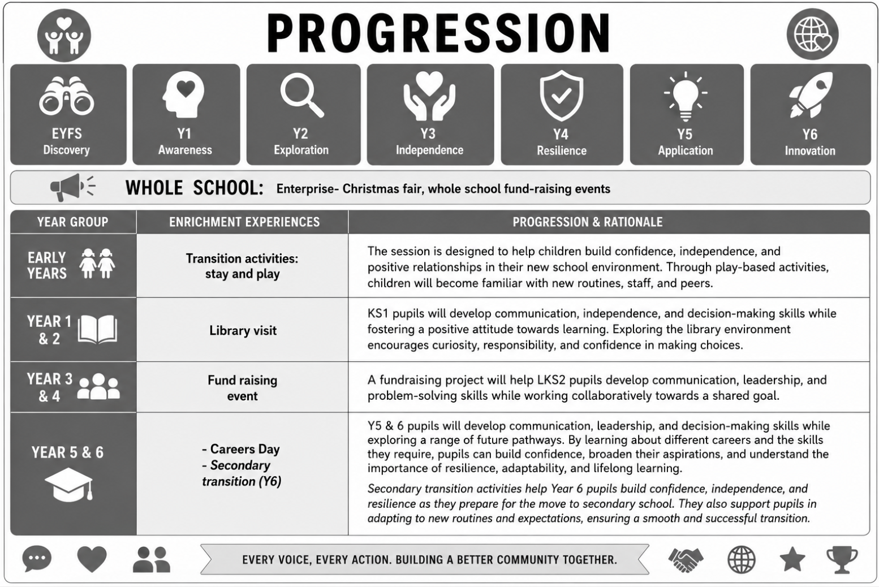

Enrichment: Extra Curricular Activities

Promoting inclusion and aspiration; ensuring all pupils have access to varied experiences that broaden their horizons.
We recognise the important role that extra-curricular opportunities play in supporting pupils' personal development. Our wide-ranging programme of clubs extends learning beyond the classroom, providing pupils with opportunities to explore interests, develop new skills and discover talents that may not emerge through the academic curriculum alone.
Through participation in sport, the arts, creative activities, practical experiences and academic enrichment, pupils are encouraged to broaden their horizons, build confidence and develop a lifelong love of learning. We are committed to ensuring that all pupils have access to a rich range of opportunities that enhance their experiences, raise aspirations and contribute to their cultural capital.
Our clubs are carefully designed to complement the wider curriculum while promoting the key personal qualities that enable children to thrive. Through regular participation, pupils develop teamwork, resilience, independence, leadership and communication skills, whilst learning the value of commitment, effort and perseverance. Clubs also provide valuable opportunities for pupils to take initiative, collaborate with others and develop positive relationships with peers who share similar interests.
Beyond skill development, our extra-curricular offer helps foster a strong sense of belonging and connection to the school community. By participating in clubs, pupils gain confidence, develop self-esteem and experience success in a variety of contexts, supporting their wellbeing and personal growth.
Through our commitment to enrichment, we aim to ensure that every child has access to meaningful experiences that inspire curiosity, nurture talent and prepare them to become confident, well-rounded individuals ready to flourish both in school and beyond.

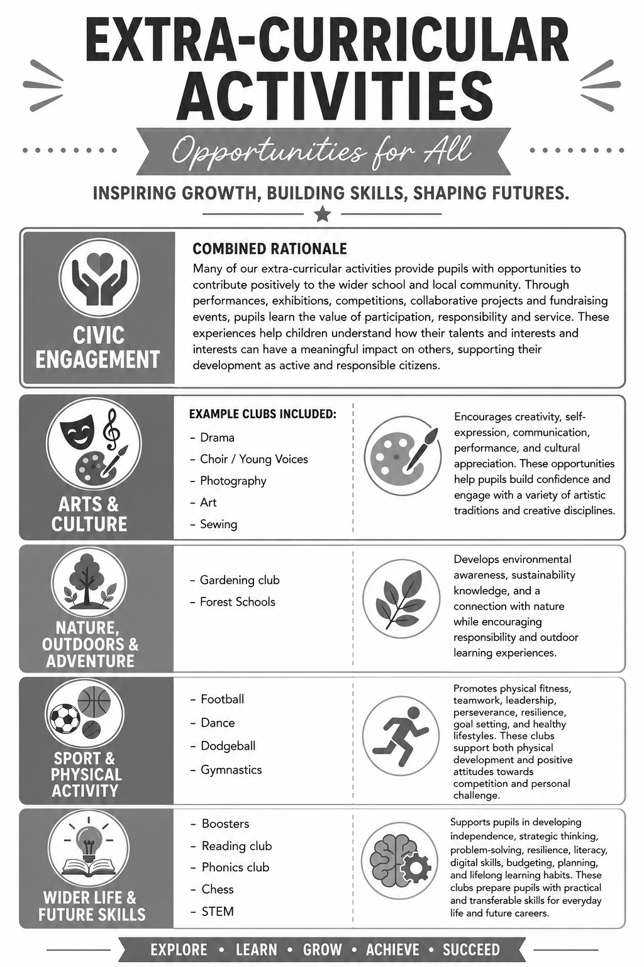

Pupil Leadership

We are committed to developing responsible, confident and active citizens who understand the positive contribution they can make to their school, local community and wider society. Pupil leadership forms an important part of our Personal Development Offer, giving children meaningful opportunities to develop character, confidence, communication skills and a strong sense of responsibility.
Through a range of carefully planned leadership roles, pupils are encouraged to take an active part in school life and to contribute to decision-making and school improvement. These opportunities help children develop teamwork, accountability, resilience and respect for others, whilst fostering a sense of pride in serving their community.
We believe that leadership is about making a positive difference and empowering others. Through their roles, pupils learn that their voice matters, their actions have impact and that everyone can contribute to creating a successful and inclusive school environment. Leadership opportunities also support pupils' understanding of democracy, citizenship and active participation, preparing them to become thoughtful and responsible members of society.
Pupil leadership roles are valued and purposeful. Children receive clear responsibilities, appropriate training and opportunities to represent the views of their peers, helping them to develop the confidence, skills and character needed to thrive both now and in the future.

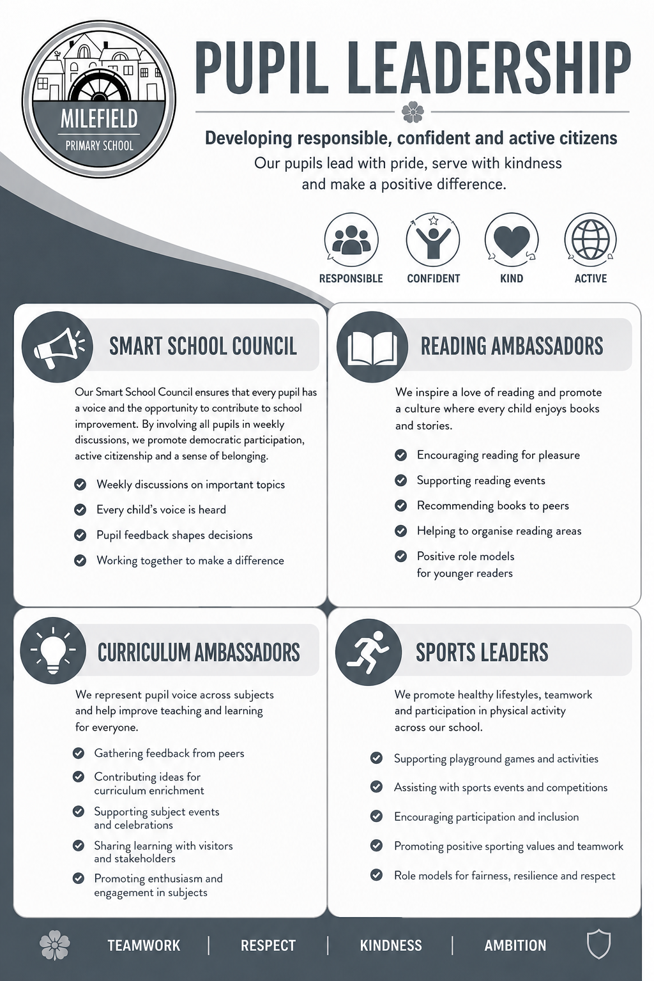
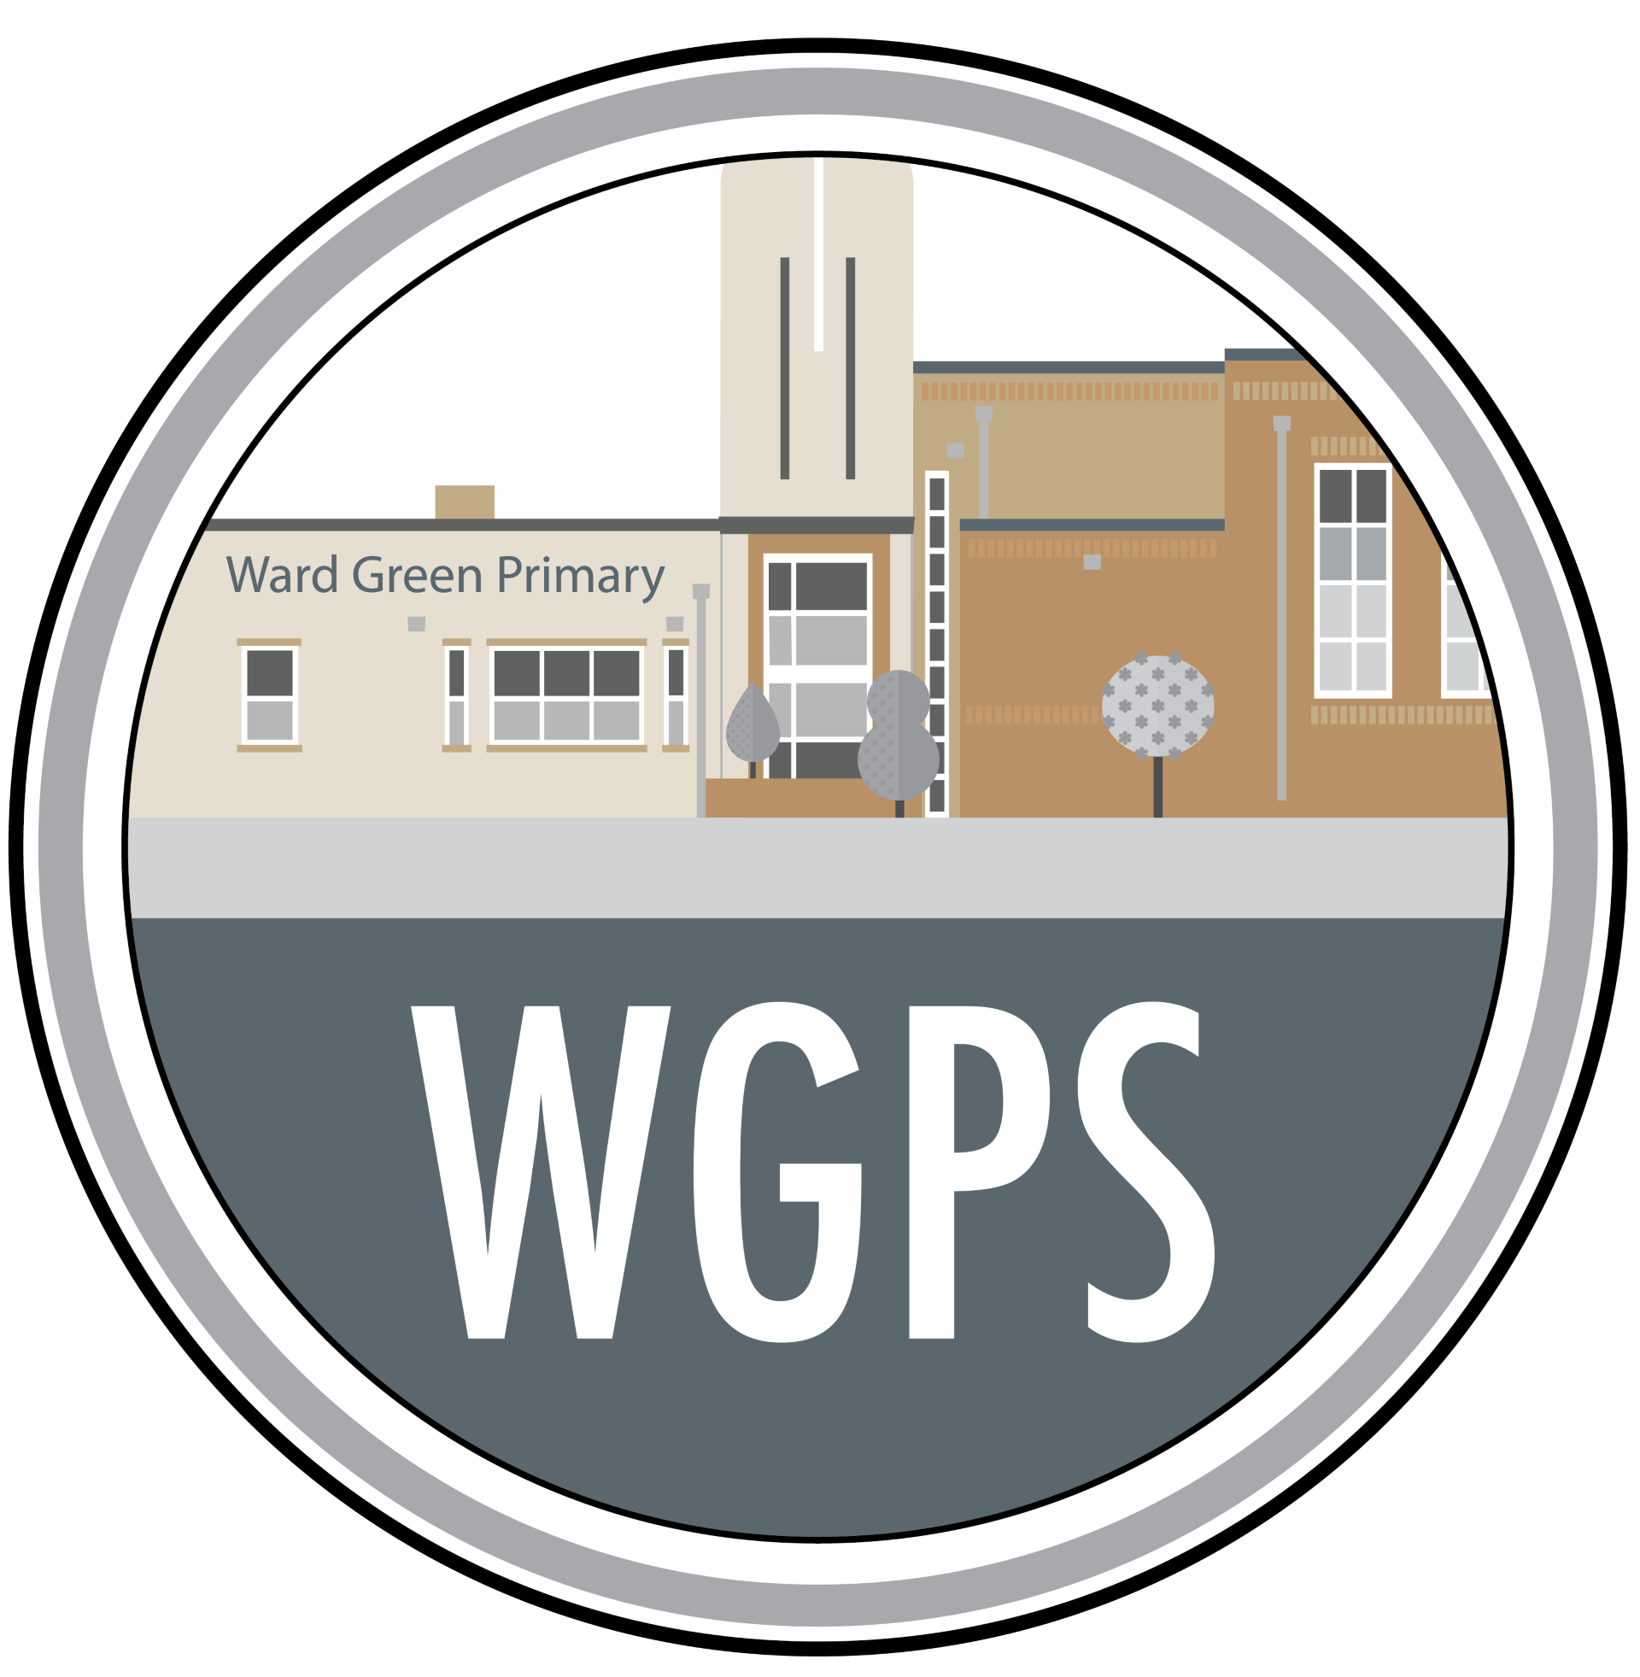

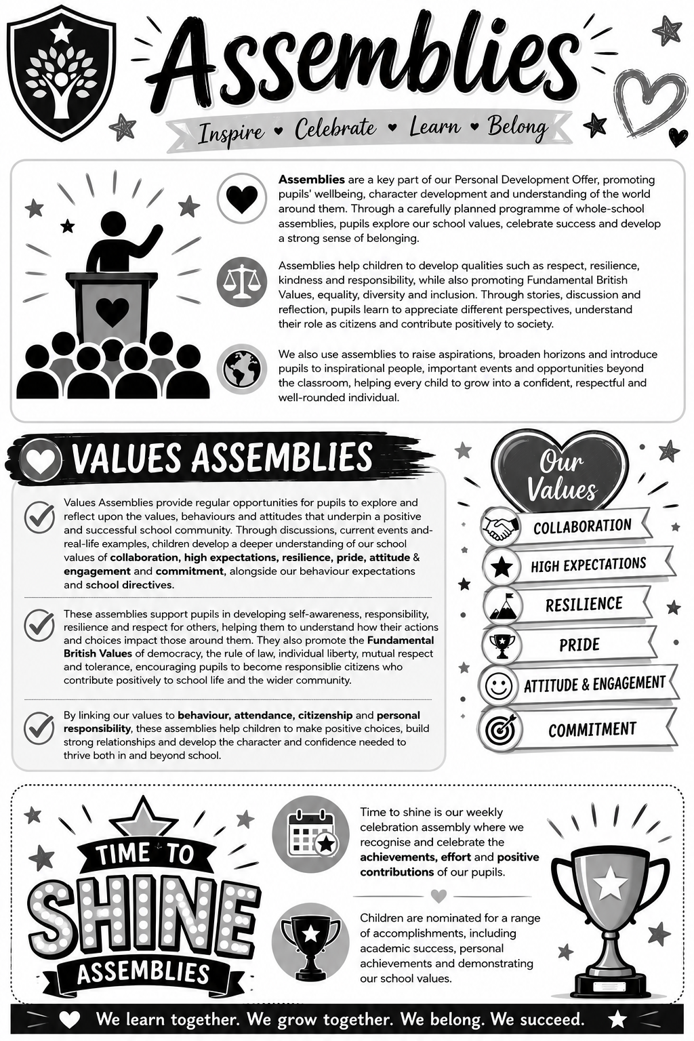
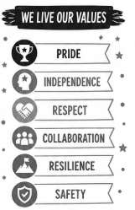

PSHE Workshops

PSHE workshops and assemblies play a vital role in supporting pupils’ personal development by providing structured opportunities to explore important themes such as relationships, health, wellbeing, safety and life skills. Through engaging, age-appropriate sessions, pupils are able to deepen their understanding of key issues, reflect on their own experiences and develop the knowledge needed to make informed decisions.

These experiences complement the wider curriculum by allowing pupils to engage with real-life scenarios and hear from a range of voices, including external specialists where appropriate.
