HCAT Academy Trust Handwriting Policy
This policy sets out the expectations for teaching handwriting across the Trust in line with the DfE Writing Framework. Consistency in approach ensures all pupils develop fluent, legible handwriting that supports their wider writing development, while still allowing schools to implement a handwriting scheme that best suits their context.
The Writing Framework (DfE, 2025) highlights the importance of teaching transcriptional skills (handwriting and spelling) from EYFS. Developing automaticity in these areas enables children to focus their working memory on composition, ensuring writing fluency and stamina.
Across Hoyland Common Academy Trust, handwriting teaching will:
- Develop pupils’ ability to write with fluency, legibility and increasing speed.
- Ensure transcriptional skills (handwriting and spelling) become automatic.
- Support children to take pride in the presentation of their work.
- Provide progression from early mark-making in EYFS through to fluent, joined handwriting in Key Stage 2.
- Enable pupils to apply their handwriting consistently across the curriculum.

Pencil Grip
Before pupils are ready to begin writing, we recognise the importance of developing a proper pencil grip to prepare them effectively. We assess pencil grip at each of our assessment points and record the developmental stage to monitor progress. When pupils need additional support to establish a strong and efficient grip, targeted interventions are provided based on the individual developmental needs of each child.
Stage | Description | Image | Developmental notes
Palmar Supinate Grasp | - Pencil is held in the palm with fingers wrapped around it  - Thumb is positioned on top or alongside the fingers  - Arm and shoulder guide the movement  - Large, sweeping motions are used for mark-making  - Often used for scribbling and early drawing | 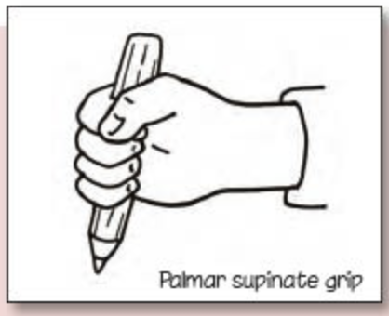 | - This grip is not efficient for controlled writing but is a natural and necessary stage in motor development.  - It lays the foundation for more refined grips as the child’s fine motor skills and hand-eye coordination improve.  Interventions  Goal: Develop finger strength and coordination to transition to Digital Pronate Grasp.  - Large vertical surface drawing (e.g., chalk on easel or wall)  - Finger painting and handprint art  - Playdough squeezing, rolling, and pinching  - Object transfer using whole hand (e.g., pom-poms, blocks)  - Gross motor activities (e.g., crawling, climbing) to build shoulder stability
Digital Pronate Grasp | - Pencil is held with fingers pointing down toward the paper  - Palm faces downward  - Movement is guided by the arm and shoulder  - Increased control compared to the Palmar Supinate Grasp  - Used for early drawing and scribbling | 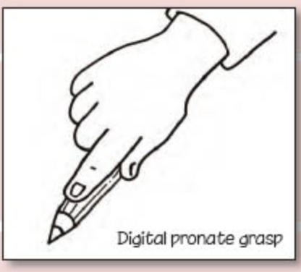 | - This grip is a transitional stage between the immature palmar grasp and more refined tripod grips  - It reflects growing neuromuscular control and hand-eye coordination  - Children may still use large movements and tire easily  Interventions  Goal: Encourage finger isolation and wrist stability to move toward Four-Finger or Static Tripod Grasp.  - Crayon rocks or short stubby pencils to promote finger use  - Threading large beads or pasta  - Peg boards and posting activities  - Vertical surface drawing to encourage wrist extension  - Scooping and pouring with small containers
Static Tripod Grasp | - • Pencil held with thumb, index, and middle fingers  - • Fingers are positioned correctly but remain relatively still  - • Wrist and forearm guide movement  - • Increased control compared to earlier grips  - • Used for early writing and drawing tasks | 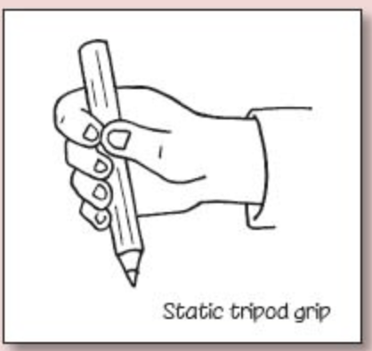 | - This grip is a precursor to the Dynamic Tripod Grasp  - Children may still tire easily or show inconsistent pressure  - Encouraging fine motor activities can help transition to dynamic finger movement  Interventions  Goal: Refine finger placement and reduce reliance on extra fingers to transition to Static Tripod Grasp.  - Use triangular pencils or pencil grips  - Tweezer games and small object sorting  - Cutting with child-safe scissors  - Lacing cards and sewing boards  - Finger gym activities (e.g., finger push-ups, finger taps)
Inverted Tripod Grasp | - Pencil held with three fingers, but with atypical positioning  - Thumb may wrap over or press against the pencil in a controlling way  - Index finger may curl or dominate the grip  - Movement may be less fluid and controlled  - Can lead to increased hand fatigue or reduced writing efficiency | 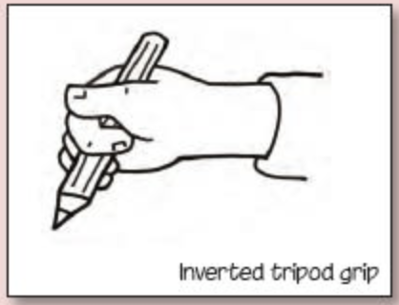 | - Often seen in children who have not yet developed full fine motor control or who have adapted their grip for comfort  - May require targeted fine motor interventions to transition to a more functional grip  - Not considered ideal for sustained writing tasks  Interventions  Goal: Maintain and refine grip for fluent, fatigue-free writing.  - Regular handwriting practice with varied tools  - Fine motor warm-ups before writing tasks  - Encourage self-monitoring of grip and posture  - Use of writing prompts and journaling  - Continued finger dexterity games (e.g., origami, coin flipping)
Dynamic Tripod Grasp | - Pencil rests against the side of the middle finger  - Thumb and index finger pinch the pencil  - Fingers move independently to control the pencil  - Wrist and forearm remain stable  - Enables fluent, legible handwriting with minimal fatigue | 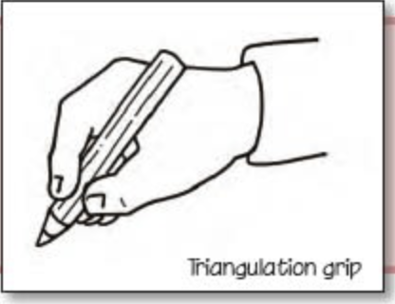 | - This grip supports sustained writing and drawing tasks  - Often emerges after consistent fine motor practice and exposure to writing tools  - Encouraging activities like threading, tweezers, and small construction can support its development

Developmental Stages of Handwriting
We assess handwriting at each of our assessment points and record the developmental stage to monitor progress. When pupils need additional support to establish a fluent approach, targeted interventions are provided based on the individual developmental needs of each child.
 | Emergent Mark-Making | Pre-Writing Shapes | Letter-Like Shapes | Print Formation | Developing fluency | Fluent
Posture | I can explore movement through play and mark-making on large surfaces | I can develop core strength and shoulder movement  I can sit on a chair at a table with feet flat on the floor | I can sit on a chair with a straight back touching the seat  I can sit with the chair tucked close in under the table | I can sit using the appropriate posture for handwriting consistently  I can sit using the correct handwriting posture for a sustained period of time | I can sit with the chair tucked close in under the table | I can sit using the appropriate posture for handwriting consistently  I can sit using the correct handwriting posture for a sustained period of time
Formation | Can enjoy drawing freely  Can give meaning to marks  Can make marks on paper to stand for their name  Can explore different materials and tools to make a simple drawing using continuous lines to make shapes  Begins to make preliterate scribble to carry meaning  Symbolic mark making to carry meaning | Can draw a recognisable picture  Can copy write first name using name card  Can pretend write when playing including some familiar letters  Directional mark making using representations of letters | I can use phonetical rhymes to form letters  I can begin to use pre-cursive patterns to develop familiarity with handwriting families  I can show accuracy and care when forming letters  I can place letters on the line appropriately  I can begin to form lower-case letters in the correct direction, starting and finishing in the right place  I can print all lower case and capital letters  I can understand which letters belong to which handwriting ‘families’ (ie letters that are formed in similar ways) | I can form lower-case and capital letters of the correct size relative to one another  I can begin to use some of the diagonal (arm join) and horizontal (washing line) strokes needed to join letters  I can use spacing between words that reflects the size of the letters  I can begin to use pre-cursive lower-case letter formations | I can use the diagonal and horizontal strokes that are needed to join letters.  I can use appropriate joins for double letters in words (e.g. rr)  I can use downstrokes of letters that are parallel and equidistant,  I can make sure that lines of writing are spaced sufficiently so that the ascenders and descenders of letters do not touch  I can use accurately use cursive handwriting | I can use consistent size and spacing with joined handwriting  I can choose the shape of a letter to use when given choices and deciding whether or not to join specific letters.  I can develop my own handwriting style
Fluency | I can experiment with mark-making tools and surfaces | I can begin to control tools with increasing precision | I can develop letter formation by controlling the size of the letters using additional lines and visual prompts  I can write simple phrases and sentences that can be read by others. | I can complete a simple dictation sentence with legible, print handwriting  I can complete a paragraph with letters that are consistently sized and spaced | I can begin to develop fluent, even handwriting:  - Letters are consistently sized  - Known joins are used correctly  - Ascenders and descenders are parallel  - Regular spaces within and between words.  I can develop joined writing fluency, speed and stamina | I can show an awareness of the following three speeds of writing:  - Speed one: slower, neat writing for publishing  - Speed two: Fast and legible everyday writing  - Speed three: Note writing – may be print but can be read by the writer.
Intervention/Support | Goal: Encourage exploration and enjoyment of mark-making.  Posture Interventions  Gross motor play: Crawling, climbing, dancing to build core strength.  Large surface activities: Chalk on playgrounds, painting on easels, sand trays.  Tummy time drawing: Promotes shoulder stability.  Formation Interventions  Sensory trays: Use sand, shaving foam, or rice for free drawing.  Finger painting: Builds finger strength and control.  Story-based drawing: Encourage children to “tell a story” with their marks.  Fluency Interventions  Tool exploration: Crayons, chunky pencils, paintbrushes.  Vertical surfaces: Whiteboards or easels to promote wrist extension.  Music and movement: Drawing to rhythm or beats. | Goal: Develop control and awareness of basic shapes.  Posture Interventions  Core exercises: Animal walks, yoga poses (e.g., “table” or “bridge”).  Seated balance games: Sitting on wobble cushions or therapy balls.  Formation Interventions  Tracing shapes: Circles, lines, zigzags using fingers and tools.  Shape hunts: Find and draw shapes in the environment.  Multi-sensory tracing: Sandpaper letters, playdough shapes.  Fluency Interventions  Controlled scribbling: Within boundaries or shapes.  Dot-to-dot activities: Reinforce shape formation.  Pattern copying: Simple repeating patterns. | Goal: Begin symbolic representation and early letter awareness.  Posture Interventions  Table-top activities: Encourage sitting with feet flat and back straight.  Chair checks: Ensure proper height and support.  Formation Interventions  Name writing practice: Using name cards and tracing.  Letter play: Magnetic letters, foam letters in water.  Pre-cursive patterns: Rainbow writing, sky-writing with arms.  Fluency Interventions  Letter hunts: Find letters in books or around the room.  Role play writing: Menus, shopping lists, signs.  Controlled drawing: Encourage consistent size and spacing. | Goal: Develop accurate letter formation and placement.  Posture Interventions  Posture reminders: Visual cues on desks, posture songs.  Fine motor warm-ups: Finger aerobics, squeezing stress balls.  Formation Interventions  Handwriting families: Teach similar letter formations together.  Line guides: Use highlighted or double lines for placement.  Letter formation rhymes: E.g., “Start at the top and pull down for ‘l’.”  Fluency Interventions  Dictation practice: Short phrases with focus on neatness.  Letter spacing games: Use finger spaces or spacers.  Copying sentences: Focus on consistency. | Goal: Introduce joins and improve consistency.  Posture Interventions  Posture checks: Encourage self-monitoring.  Stamina building: Gradually increase writing duration.  Formation Interventions  Joining practice: Teach diagonal and horizontal joins explicitly.  Spacing awareness: Use visual prompts or grid paper.  Cursive introduction: Begin with common joins.  Fluency Interventions  Paragraph writing: Focus on legibility and spacing.  Timed writing: Build speed while maintaining quality.  Peer editing: Encourage awareness of presentation. | Goal: Develop personal style and adapt writing speed.  Posture Interventions  Ergonomic awareness: Discuss pen grip, posture, and fatigue.  Writing stamina: Longer tasks with breaks.  Formation Interventions  Style choice: Allow exploration of cursive vs. print.  Consistency checks: Self-assess size and spacing.  Fluency Interventions  Speed training: Practice three speeds of writing.  Note-taking practice: Encourage shorthand or quick legible writing.  Publishing tasks: Neat writing for display or sharing.

Teaching Expectations
- Reception & Key Stage 1: Handwriting is taught explicitly and regularly, beginning with mark-making, correct pencil grip, posture and letter formation. By the end of KS1, pupils should form letters correctly and begin to develop a joined style.
- Key Stage 2: Teaching continues to refine and secure a fluent, legible style, with emphasis on writing stamina and appropriate speed for different purposes. Pupils are expected to apply handwriting consistently across all subjects.
- Inclusion: Pupils with additional needs will receive targeted support and reasonable adjustments will be made to ensure they can develop handwriting fluency.

Teaching Approaches
- Handwriting should be taught explicitly and discretely, with opportunities for practice across the curriculum.
- Teachers and teaching assistants model handwriting consistently, both on the board and in feedback.
- Resources, environment and classroom displays should support correct letter formation.

Schemes and Resources
Each school within the Trust will identify and implement an agreed handwriting scheme that aligns with the principles above.
The

Progression in Handwriting
The following grid outlines handwriting expectations across year groups, aligned with the Writing Framework:

Assessment and Monitoring
- Teachers assess pupils’ handwriting progression in line with the Writing Framework expectations.
- Subject leaders and senior leaders will monitor the consistency and quality of handwriting teaching across the school.
- Trust-wide moderation may include handwriting as part of writing outcomes reviews.

