




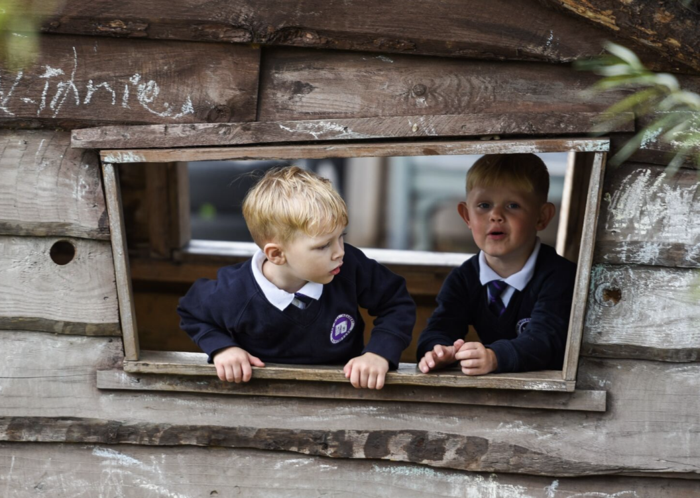



The Mill Academy


Anti-Bullying Policy


This policy will be reviewed at least annually and following any concerns and/or updates to national/local guidance or procedure.

Objectives of this Policy
The Mill Academy is committed to providing a safe and inclusive learning environment for all students. We recognize the harmful impact of bullying on individuals’ well-being and academic achievement. Our anti-bullying policy is grounded in the latest research and best practices to effectively prevent and address bullying.
This policy explains the steps The Mill Academy will take to prevent and address bullying. It has been developed with the involvement of the whole school community, and we are dedicated to fostering a culture where bullying of any kind—whether between adults, children, or young people—will not be tolerated.

Definition of Bullying
Bullying is defined as repeated, intentional, and harmful behaviour—whether physical, verbal, or psychological—that involves a power imbalance and causes distress or harm to an individual or group. This includes cyberbullying, prejudice-based bullying, and discriminatory bullying.
According to the Department for Education (DfE, Preventing and Tackling Bullying, July 2017), bullying is:
“Behaviour by an individual or a group, repeated over time, that intentionally hurts another individual either physically or emotionally.”
Examples of bullying include:
- Name calling, taunting, mocking, offensive comments
- Physical aggression such as kicking, hitting, or taking belongings
- Producing offensive graffiti, gossiping, excluding others, or spreading untruthful rumours
Bullying also occurs online, often referred to as cyberbullying. This can include:
- Sending offensive, upsetting, or inappropriate messages via phone, text, instant messenger, gaming platforms, websites, or social media
- Sharing degrading or offensive photos or videos
The Mill Academy recognises bullying as a form of child-on-child abuse. It can be emotionally damaging and cause severe, lasting effects on children’s emotional and social development.

Forms of Bullying
Bullying can affect anyone. This policy covers all forms, including:
- Physical
- Emotional
- Sexual
- Bullying related to race, religion, faith, or lack of faith
- Bullying related to ethnicity, nationality, or culture
Emotional bullying may include:
- Bullying related to SEND (Special Educational Needs or Disability)
- Bullying related to appearance or physical/mental health conditions
- Bullying related to sexual orientation (homophobic / biphobic / transphobic bullying)
- Bullying of young carers, children in care, or children affected by home circumstances
- Gender-based bullying, including transphobic bullying
- Peer-to-peer bullying
- Cyberbullying (bullying via technology)

Our School Community
At The Mill Academy, our school community:
- Discusses, monitors, and reviews our anti-bullying policy and practices regularly.
- Supports all staff to foster positive relationships and intervene appropriately to address bullying.
- Ensures pupils understand that bullying concerns will be taken seriously, handled sensitively, and resolved effectively.
- Communicates with parents/carers about bullying concerns and responds promptly to complaints. Parents/carers work with the school to support the anti-bullying policy.
- Learns from effective anti-bullying practices elsewhere and collaborates with relevant organisations when appropriate.

Preventing, Identifying, and Responding to Bullying
Education and Awareness:
We prioritise comprehensive anti-bullying education that promotes empathy, respect, and positive relationships. These lessons are embedded across the curriculum, equipping pupils with the skills and knowledge to prevent and respond to bullying.
School Culture:
We nurture a positive and inclusive school culture that values diversity, promotes kindness, and encourages pupils to speak out against bullying. We celebrate differences and actively challenge prejudice and stereotypes.
Peer Support and Mentoring:
We run peer support programmes where older pupils guide and mentor younger ones. These initiatives encourage supportive role modelling, foster a sense of belonging, and strengthen the school’s supportive community.
The Mill Academy community will:
- Build and maintain an inclusive environment based on respect, care, and consideration.
- Work with staff and external agencies to address all forms of prejudice-driven bullying.
- Provide structured opportunities to help pupils build resilience, develop social and emotional skills, and strengthen well-being.

Preventing, Identifying and Responding to Bullying
The Mill Academy is committed to a whole-school approach to tackling bullying.
We will:
- Provide pupils, staff, and parents/carers with accessible ways to seek support and report concerns.
- Challenge behaviours and practices that fail to uphold values of tolerance, non-discrimination, and respect.
- Embed anti-bullying awareness throughout the curriculum and school life, supported by displays, assemblies, peer mentoring, and the school/student council.
- Regularly review strategies in light of new technologies and provide up-to-date education on safe and respectful online behaviour.
- Train all staff—including teachers, support staff, administrative staff, lunchtime supervisors, and pastoral staff—to identify and address bullying, following school procedures for recording and reporting.
- Record all incidents of bullying on Arbor in line with our behaviour policy, monitoring trends and patterns.
- Establish safe spaces for vulnerable children and young people.
- Use restorative and proactive approaches to resolve conflicts between those affected by bullying.
- Collaborate with external agencies and the wider school community to prevent and address issues.
- Celebrate achievements to build and promote a positive school ethos.

Reporting and Responding
- Reporting Mechanisms: Clear and confidential reporting systems are available for students, staff, and parents. Reports can be made in person or through designated staff.
- Support and Intervention: Immediate support is provided to students experiencing bullying to ensure their well-being and safety. Staff respond promptly and sensitively.
- Investigation and Consequences: All reports are thoroughly investigated. When bullying is confirmed, appropriate actions are taken in line with the school’s behaviour policy. Consequences focus on education, rehabilitation, and preventing recurrence.
- Restorative Practices: We use restorative approaches to rebuild relationships and resolve conflict, encouraging accountability, empathy, and positive change.

Involvement of Pupils
The Mill Academy will:
- Gather pupils’ views on bullying regularly.
- Ensure pupils know how to share worries and anxieties.
- Make pupils aware of possible sanctions for bullying behaviours.
- Involve pupils in anti-bullying campaigns and embed anti-bullying messages across the curriculum.
- Promote helplines and support services.
- Support both those who have been bullied and those who display bullying behaviours, addressing underlying concerns.

Liaison with Parents and Carers
We will:
- Provide parents with accessible information about bullying, policies, and points of contact.
- Ensure parents know who to contact regarding concerns.
- Share the school’s complaints procedures clearly.
- Signpost parents to independent advice services.
- Work in partnership with parents and the local community to address issues beyond the school gates.
- Encourage parents to role model positive behaviour both online and offline.

Collaboration and Community Engagement
- Partnerships: We collaborate with parents, carers, external agencies, and the wider community to ensure effective anti-bullying practices.
- Staff Training: Regular training and professional development are provided for staff to strengthen skills in recognising and addressing bullying.

Responsibilities
It is the responsibility of:
- School Governors to monitor and review the policy.
- Governors, Headteacher, Senior Managers, Teachers, and Support Staff to implement and uphold the policy.
- The Headteacher to communicate the policy across the school community.
- Staff to support and apply the policy.
- Parents/Carers to support their children and work in partnership with the school.
- Pupils to respect and follow the policy.

Monitoring and Review
- The Headteacher and safeguarding lead report termly to the Governing Body on incidents and trends.
- Section 175 Safeguarding Audit is completed annually and submitted to the Local Authority.
- The Safeguarding Governor is informed of all bullying incidents and includes findings in monitoring reports.
- The policy and its effectiveness are reviewed regularly, with feedback from staff, pupils, parents, and stakeholders. Adjustments are made where necessary to ensure a safe and inclusive school environment.

Links with Legislation
This policy is based on:
- DfE guidance Preventing and Tackling Bullying (July 2017)
- DfE statutory guidance Keeping Children Safe in Education (2021)
- Guidance on Sexual violence and sexual harassment between children in schools and colleges
It also links with:
- Education and Inspection Act (2006, 2011)
- Equality Act (2010)
- Children Act (1989, 2004)
- Protection from Harassment Act (1997)
- Malicious Communications Act (1988)
- Public Order Act (1986)
- Computer Misuse Act (1990)

Related Policies
This Anti-Bullying Policy should be read in conjunction with:
- Behaviour Policy
- Complaints Policy
- Safeguarding and Child Protection Policy
- e-Safety and Acceptable Use Policies
- Curriculum Policies, including the Home/School Agreement

Useful Links
- Anti-Bullying Alliance: www.anti-bullyingalliance.org.uk
- Childline: www.childline.org.uk
- Family Lives: www.familylives.org.uk
- Kidscape: www.kidscape.org.uk
- MindEd: www.minded.org.uk
- NSPCC: www.nspcc.org.uk
- The BIG Award: www.bullyinginterventiongroup.co.uk/index.php
- PSHE Association: www.pshe-association.org.uk
- Restorative Justice Council: www.restorativejustice.org.uk
- The Diana Award: www.diana-award.org.uk
- Victim Support: www.victimsupport.org.uk
- Young Minds: www.youngminds.org.uk
- Young Carers: www.youngcarers.net
SEND & Cyberbullying Links:
- Changing Faces: www.changingfaces.org.uk
- Mencap: www.mencap.org.uk
- DfE SEND Code of Practice: www.gov.uk/government/publications/send-code-ofpractice-0-to-25
- Childnet: www.childnet.com
- Internet Watch Foundation: www.iwf.org.uk
- Think U Know: www.thinkuknow.co.uk
- UK Safer Internet Centre: www.saferinternet.org.uk
- UK Council for Child Internet Safety (UKCCIS): www.gov.uk/government/groups/uk-council-for-child-internet-safety-ukccis

