


HCAT
Primary Behaviour for Learning Policy
This policy should be read and used in conjunction with a range of associated Trust and school policies.

Reviewed & Updated:
July 2026

Contents
HCAT Behaviour for Learning Policy

Section 1: Policy Aims
Secction 2: School Vision & Values
Section 3: Behaviour Principles and Strategies
Section 4: Expectations
Section 5: Praise & Recignition
Section 6: Managing Behaviour, Choices & Consequences
Section 7: Inclusion & Specialist Intervention
Section 8: Parental Involvement
Section 9: Searching, Screening & Confiscation
Section 10: Use of Reasonable Force
Section 11: Behaviour in the Community
Section 12: Staff Training, Induction & Support
Section 13: Artificial Intelligence & Online Technology
Section 14: Appendices

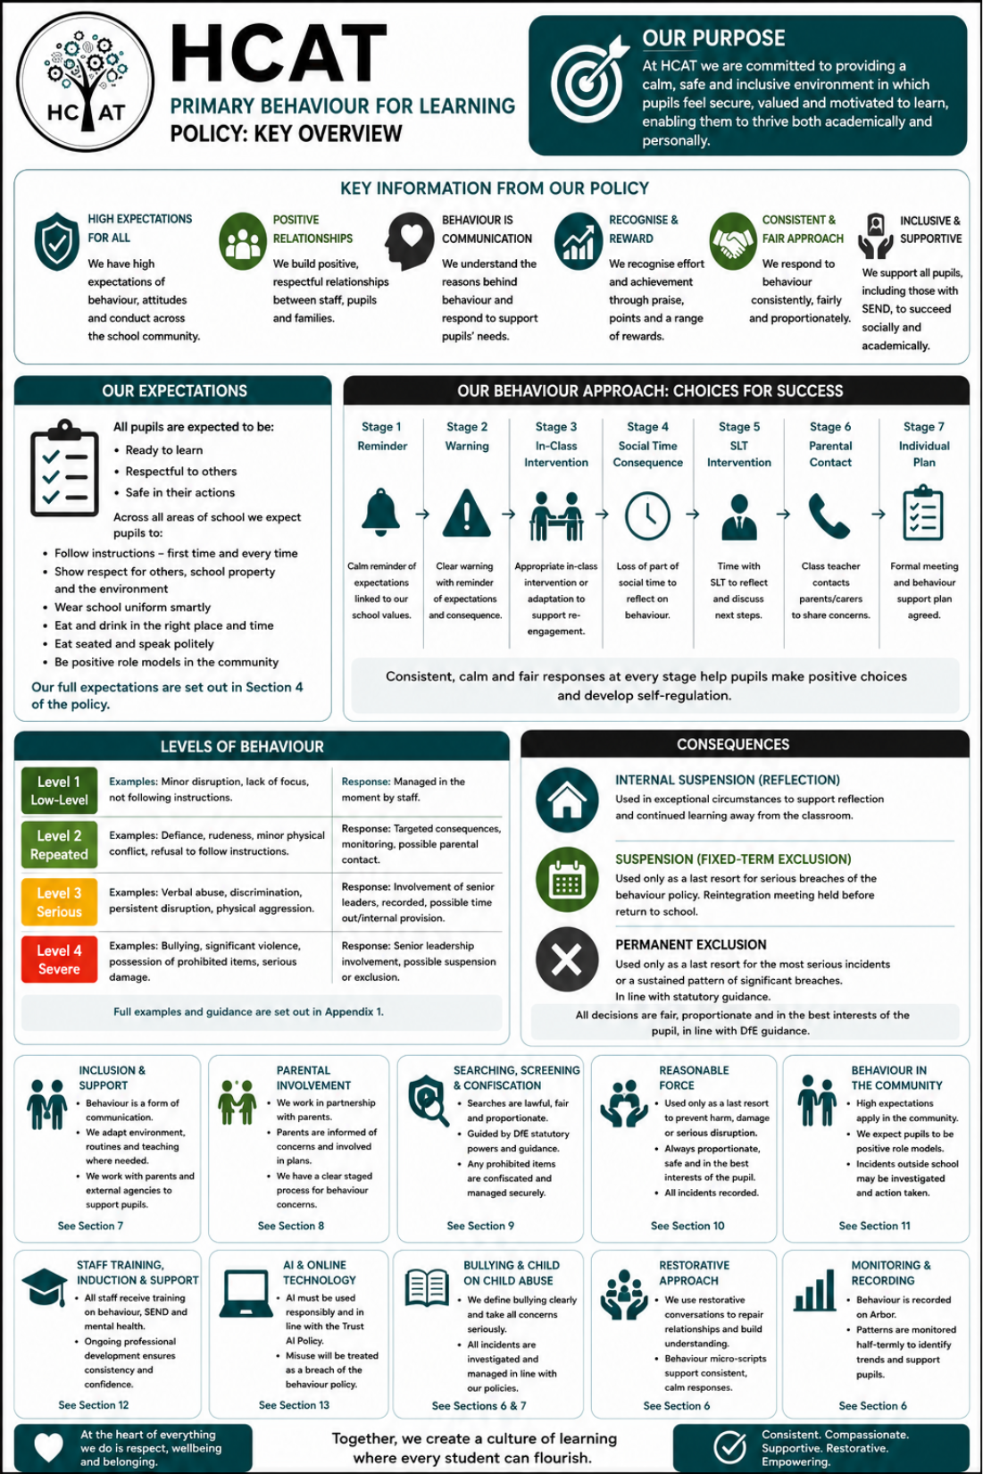

SECTION 1: Policy Aims

At HCAT we recognise that high standards of behaviour are fundamental to achieving a high-quality education. We are committed to providing a calm, safe and inclusive environment in which pupils feel secure, valued and motivated to learn, enabling them to thrive both academically and personally.

Our approach prioritises the development of positive, respectful relationships between staff, pupils and families, ensuring that all members of the school community feel supported. There is a culture of high expectations, consistency and mutual respect which is underpinned by our school vision and values.

For our Behaviour for Learning policy to be effective, it is essential that it is clearly aligned with these principles and is implemented consistently by all staff. A range of evidence-informed strategies are in place to support both pupils and staff, ensuring that behaviour is managed proactively and inclusively, with a strong emphasis on promoting positive conduct and supporting individual needs.

This policy should be used in conjunction with the following Trust/School policies:
- Safeguarding and Child Protection Policy
- Anti-bullying Policy
- RSHE Policy
- SEND Policy
- Managing Parent and Visitor Conduct Policy

This policy sets out to:
- Create a safe, calm and inclusive environment where all pupils feel valued, respected and ready to learn.
- Promote high expectations of behaviour, attitudes and conduct across the school community.
- Support pupils in developing self-discipline, resilience and responsibility for their actions.
- Encourage positive relationships built on mutual respect between pupils, staff and families.
- Recognise and reward positive behaviour while addressing inappropriate behaviour consistently and fairly.
- Ensure all pupils, including those with additional needs, are supported to succeed socially and academically.
- Prepare pupils to be responsible, respectful and active members of society.
- Encourage respect for religious and moral values and tolerance of other cultures in a multi racial society.
SECTION 2: School Vision & Values

At The Mill Academy Primary School, our vision and core values sit at the heart of everything we do and are fundamental to our Trust Behaviour for Learning policy. We are committed to creating a safe, respectful and inclusive environment where every child feels valued, confident and ready to learn. Our shared values—such as high expectations, resilience and attitude—underpin the expectations we have for behaviour and relationships across the school.

These values are actively promoted and modelled in every lesson and throughout all aspects of school life, from the classroom to the playground and beyond. Staff consistently reinforce positive behaviour, ensuring that pupils understand how their actions support both their own learning and that of others. By embedding our vision and values in daily practice, we foster a culture where high expectations, mutual respect and a love of learning thrive.
Vision:
INSPIRE: Developing a thirst for knowledge and building aspirations
ACHIEVE: Strengthening determination, resilience, and pride in success
GROW: Developing character, confidence, and resilience for life

Core Values:
- Pride- we belong to our school and are proud of our community; we show this in the uniform we wear.
- Resilience- we persevere and never give up; we know how to learn from mistakes and improve.
- Respect – we respect each other, so they valued and listened to, we build kind friendships, work well together, and create a happy place to learn and play.
- Independence – we think for themselves, make good choices, and solve problems with confidence.
- Teamwork- we work together to ensure the best possible outcomes.
- Safety - we all share the responsibility to look after ourselves and each other, making sure our school is a place where everyone feels protected and cared for.

Character Traits:
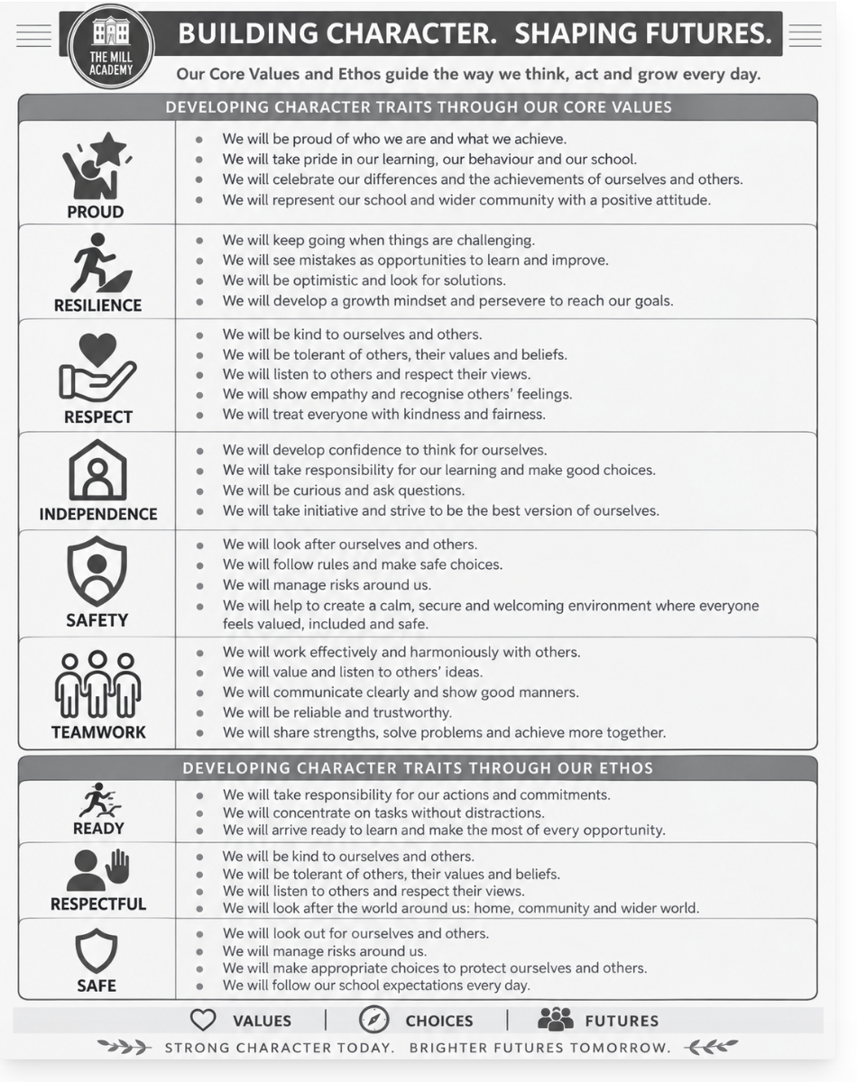

SECTION 3: Behaviour Principles & Strategies

At HCAT, positive behaviour is built on the shared expectation that all pupils are ready to learn, respectful to others, and safe in their actions at all times:
READY, RESPECTFUL, SAFE
We have high expectations of pupils’ behaviour at all times. We firmly believe that developing high quality teaching is the key to ensuring positive attitudes towards learning and encouraging all pupils to take responsibility for their own behaviours.
Our behaviour system is built on positive relationships between staff and pupils with an understanding of children’s backgrounds and previous experiences. A clear, whole-school approach ensures behaviour is managed effectively and consistently, with all members of the school community sharing responsibility for explicitly teaching and reinforcing appropriate social behaviours, values and routines. Positive descriptive praise and unconditional positive regard are the basis of our behaviour management system. Through the personal development and RSHE curriculum, pupils are taught what constitutes acceptable and unacceptable behaviour, supported by strong modelling from staff.
Staff consistently apply the school behaviour policy, explicitly reinforcing school rules and values while building strong, respectful relationships with all pupils based on deep knowledge of their needs. They actively and persistently recognise and celebrate positive behaviour, demonstrating unconditional care, compassion and a commitment to fostering a culture of mutual respect through purposeful, consistent interactions.
Relationships are central to our approach, underpinned by positive regard and an understanding of individual circumstances. Where pupils require additional support, needs are identified promptly and appropriate, proactive strategies are implemented, including specific provision for pupils with SEND within their individual plans.
Any unacceptable behaviour is addressed swiftly, consistently and proportionately.
Roles & Responsibilities:
Role | Responsibility
All staff will: | - Establish and maintain good relationships with students  - Have high expectations of behaviour and establish a framework for discipline, using praise and consequences consistently and fairly  - Explicitly teach what good behaviour looks like and model positive behaviours  - Reward or re-direct children by referring to our core values & behaviour guidelines.  - Collect and greet children at the start of the day and after each break.  - Acknowledge and reward children meeting our high expectations through phone calls home, Time to Shine certificates, praise postcards etc.  - Never ignore children who are failing to meet expectations and engage in restorative conversations  - Communicate with home following behaviour incidents
The Senior Leadership Team will: | - Be a visible presence around the school and at the start/end of the school day  - Support staff in ensuring there is a positive climate for learning.  - Support teachers in managing children with more complex or challenging behaviours  - Regularly celebrate children whose efforts go above and beyond expectations  - Encourage use of positive praise, phone calls, values cards and certificates  - Lead meetings with staff responsible for behaviour, attendance and wellbeing to review provision for pupils requiring support/intervention.  - Be responsible for Suspension and supervision of Internal Suspension, Reflection and Timeout- The Head of School is responsible for, and makes all decisions, regarding Suspensions and Permanent Exclusions  - To lead reintegration meetings following Internal Suspension and Suspension  - Collect, collate and monitor whole school behaviour data  - Investigate, monitor and log bullying and peer on peer abuse incidents  - Monitor students on behaviour reports  - Support with restorative conversations where necessary  - Provide governors with termly updates on behaviour  - Ensure staff are provided with continuing professional development to support positive behaviour
The Pastoral Team will: | - Implement and develop proactive strategies for individual pupils to promote positive behaviour  - Investigate behaviour incidents and communicate with parents following behaviour incidents  - Support staff with behaviour incidents  - Carry out Restorative Practice where appropriate and support staff with restorative conversations  - Collect, collate and monitor pupil data on attendance, punctuality and behaviour  - Ensure new pupils arriving throughout the academic year are clear on expectations and school systems - as part of the induction process  - Support vulnerable students  - Monitor students on behaviour reports
Duty staff will: | - Be friendly and approachable  - Be aware of relevant and accepted expectations and reinforcing them  - Be consistent and fair when giving rewards or imposing agreed sanctions  - Know the children as individuals, recognising their characters and taking this knowledge into account when working with them  - Support children’s development of behaviour skills and self-regulation, with training support  - Actively monitor pupils and pre-empt any issues/incidents arising  - Inform class teachers and/or SLT about specific incidents or trends in behaviour  - Encourage respectful attitudes for others, the environment, property and equipment  - Support children with SEMH using agreed strategies  - Arrive promptly in assigned duty areas wearing high vis jackets
Pupils will: | - Work to the best of their abilities and allow others to do the same.  - Treat others with respect.  - Comply with the instructions of all members of staff.  - Take care of the school property and environment.  - Cooperate with other children and adults.
Parents and carers will: | - Work in partnership with school to ensure consistent messages are given about expected behaviours  - Support the school’s rules and policies and support school in upholding sanctions if their child fails to comply with rules/expectations  - Always make their child aware of appropriate behaviour.  - Inform school about any issues at home that might affect a child’s learning or behaviour  - Send their child to school regularly and on time, ready for the day e.g., Uniform, PE Kit and notify school if there is a legitimate reason why their child is absent or late, or of any other issues that might affect their child’s progress.  - Be available for contact throughout the course of the school day and to attend meetings to discuss their child’s progress, as and when required

Behaviour Management Strategies:
- Clear Expectations: We establish clear and consistent behaviour expectations across all areas of the school, including classrooms, corridors, and communal spaces. These expectations are communicated to students, staff, parents, and visitors to ensure a shared understanding.
- Proactive Approaches: We employ proactive strategies to prevent disruptive or challenging behaviour, such as establishing routines, providing engaging and lessons that meet the needs of all pupils through adaptive teaching, and promoting a sense of belonging and inclusion.
- Restorative Practices: We promote restorative practices to address incidents of disruptive behaviour or conflicts. These practices focus on repairing harm, restoring relationships, and building empathy and understanding.
- Individual Support Plans: For students with specific behavioural needs, we develop individual support plans in collaboration with parents/carers, external agencies, and relevant professionals. These plans outline targeted strategies, interventions, and support to meet the student's unique needs.

Transition
Inducting incoming pupils: The school will support incoming pupils to meet behaviour standards by offering an induction process to familiarise them with the behaviour policy and the wider school culture.
Preparing outgoing pupils: To ensure a smooth transition to the next year, pupils have transition sessions with their new teacher(s). In addition, staff members hold transition meetings. To ensure behaviour is continually monitored and the right support is in place, information related to pupil behaviour issues may be transferred to relevant staff at the start of the term or year.

Playtime Supervision
All pupils will be escorted to and from the playground to ensure they start playtime in a calm manner. When on duty, staff will circulate and take the opportunity to socialise with children from other classes, whilst maintaining an overview of the play area and spotting potential problems before they escalate. Staff will consider their own positioning to maximise levels of visual supervision. If a rule is broken at break or lunch time, staff on duty will deal with accordingly, if appropriate, staff will communicate this to the class teacher who will deal with the issue in line with the policy. SMSAs report back to the class teacher at the end of lunchtime.

Breakfast club
All pupils are invited to attend breakfast club, although pupils are free to choose from the range of activities available, we expect them to abide by the school rules at all times. In the case of severe breaches of these rules, the offer of a place may be withdrawn.

Extra-Curricular activities and clubs
All pupils are invited to choose from a variety of clubs to enrich their learning experiences. All pupils attending will be expected to follow the school rules at all times. In the case of severe breaches of these rules, the offer of a place may be withdrawn.

School Trips
Where a pupil’s behaviour results in them being unable to attend planned school trips/visits due to them posing a threat to the safety of themselves or others i.e., absconding, refusal to follow directions from staff or aggression towards others, parents will not be offered refunds for any monies paid and will accept this is a consequence of their pupil’s behaviour in school.

Each case will be decided upon individually according to circumstances and the parents will be informed as soon as possible.

Where a child is unable to attend such trips/visits, as a consequence of their behaviour, alternative educational activities will be planned in school. Children are still expected to attend school and parents have a legal responsibility to make sure they do as set out under our attendance policy and in line with Government requirements.

SECTION 4: Expectations

Around School:
- Follow instructions and all reasonable requests from all staff – first time and every time
- Wear school uniform smartly at all times
- Show respect for others and school property
- Always place litter in bins
- Do not enter out of bounds areas
- Eat and drink in the right place and at the right time – whilst eating remain seated, don’t shout, or raise your voice, and dispose of litter.

In the Classroom:
- Speak respectfully to staff and other pupils
- Follow instructions from all staff – first time and every time
- Listen when the teacher is talking to you
- Be ready to learn with all required equipment
- Stay on task and complete all tasks to the best of your ability
- Do not disturb another pupil for any reason
- Leave the classroom tidy

Trips/Visits:
- Be a positive role model for the school
- Behave in a mature and sensible manner
- Listen to staff instructions carefully
- Follow staff instructions
- Behave well on the bus and follow any necessary safety regulations
- Keep the bus tidy and clean

SECTION 5: Rewards & Recognition
We recognise the importance of rewarding effort, celebrating achievement, and encouraging pupils to meet and exceed high expectations. A clear and consistent approach to rewards and praise ensures that all pupils are acknowledged and motivated through a structured system of recognition.
A wide range of rewards are used to reinforce positive behaviour and achievement, including verbal praise, achievement points, certificates, celebratory events, and communication with parents and carers. Achievements are recorded and shared regularly to ensure pupils’ successes are recognised both within school and at home. We promote intrinsic motivation as a key driver of positive behaviour for learning, alongside a consistent culture of unconditional positive regard for all pupils.

As a school we offer a range of rewards to:
- Recognise the value of pupils’ achievements, progress, and effort
- Give positive encouragement to pupils to succeed and to contribute to school life
- Improve pupils’ sense of self confidence and worth

The Mill Academy operates a structured points system through which pupils are rewarded for demonstrating positive learning behaviours, achievements, adherence to school rules, and the school’s core values. Points are accumulated over time, with milestone achievements recognised through certificates, access to a points shop, and additional rewards such as prize draws and class incentives.

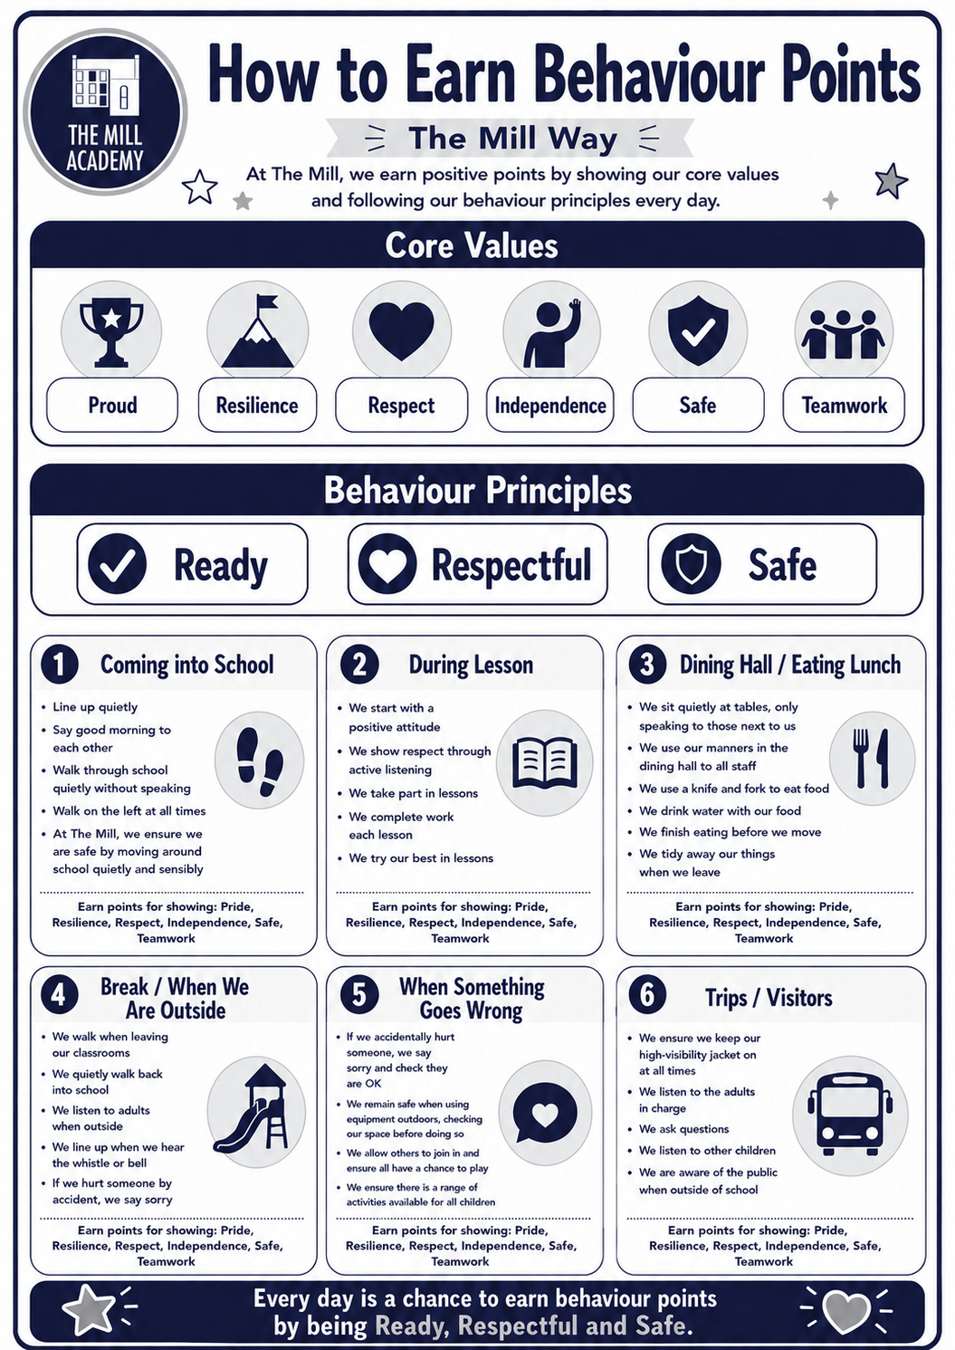
Praise Thresholds

In addition, pupils are consistently encouraged through class-based recognition, including verbal praise, stickers, certificates and prize draws ensuring that positive behaviours are acknowledged and celebrated regularly.
All Teachers are expected to:
- Recognise and reward students with points through the effective use of the 1, 2, 3 system at the end of morning and afternoon learning sessions; this is then recorded on the school points tracker.
- Teachers may also use stickers and other incentives to support pupils engage with learning.
- Teachers will have a visual weekly record of the number of points children have received in a week on display in classrooms from Y1 – Y6.
- Teachers will record the number of pupils’ points on the weekly tracker to record the number of points pupils receive over time.

Leaders are expected to:
- Ensure all teachers and support staff create a supportive and high-quality learning environment, teaching positive behaviour for learning and implementing the agreed policy with consistency.
- Regularly analyse of negative behaviours across school so that timely support can be implemented when needed.
- Regularly analyse positive points data across identify and address any relevant issues and needs.
- Meet with parents for ISBP meetings as necessary.

The Pastoral team is expected to:
Following data collection:
- Be a part of behaviour support plan meetings and reviews with parents/carers.
- Provide children will support as appropriate.
- Support pupils to develop regulation strategies.
- Offer families support with implementing consistent behaviour strategies.
- Link/referrals to outside agencies as appropriate.

Every half term:
- Once children reach 200 points or more they receive a special award from SLT which will be informed by pupil voice.

All pupils are expected to:
- Behave courteously at all times showing respect and consideration to other pupils and staff at all times
- Demonstrate Core values at every opportunity to achieve points and rewards.

SECTION 6: Managing Behaviour, Choices and Consequences

All staff have the statutory authority to address instances of unacceptable behaviour, a breach of school rules, or when reasonable instructions are not followed. Incidents are addressed promptly and discussed with pupils in an age-appropriate manner. Consequences are applied consistently and fairly, with a clear focus on identifying and addressing the behaviour.
We respond to incidents of challenging behaviour consistently and fairly, ensuring that consequences are proportionate and aligned with our behaviour policy. This consistency helps to establish clear boundaries and expectations for pupils.
Members of staff:
- Deliberately and persistently catch children doing the right thing and praise them in front of others
- Know their classes well and develop positive relationships with all children
- Relentlessly work to build mutual respect
- Demonstrate unconditional care and compassion

Where concerns arise, staff seek to understand the underlying causes of behaviour in order to respond effectively. If behaviour does not improve, a formal meeting involving the class teacher, headteacher, parents and pupil will be held to review expectations and agree clear targets. Where appropriate, a Behaviour Support Plan (BSP) will be implemented, monitored and recorded. Further review meetings may include the SENDCo to consider any additional support or needs.
The school uses a structured, graduated approach to managing behaviour, ensuring that responses are proportionate, consistent and based on professional judgement. Behaviour is viewed as a form of communication and is understood within the context of each child’s individual needs and circumstances, with a strong emphasis on positive reinforcement, de-escalation and support strategies.
Behaviours are categorised into clearly defined levels, ranging from low-level disruption addressed promptly by class staff, to more serious incidents which involve senior leaders, parental contact and, where necessary, formal interventions. Persistent or more significant concerns are monitored and recorded to identify patterns and inform next steps, including targeted support or formal meetings. In the most serious cases, sanctions may include internal isolation or suspension, in line with statutory guidance. Throughout all stages, the school prioritises early intervention, consistency, and restorative approaches to support pupils in improving their behaviour and successfully reintegrating into the school community.
Level | Overview of Behaviour | Typical Response
Level 1 | Low-level behaviours such as minor disruption, lack of focus, or not following instructions | Managed in the moment by staff using reminders, reinforcement of expectations, and low-level interventions. Repeat reminders if reasonable adjustments are necessary.
Level 2 | Repeated or more deliberate behaviours such as defiance, rudeness, or minor physical conflict | Supported through targeted consequences (e.g. missed social time), monitoring, and possible parental contact.
Level 3 | More serious incidents including verbal abuse, discrimination, persistent disruption, or physical aggression | Involvement of senior leaders, formal recording, parental communication, and possible time out or internal provision.
Level 4 | Severe behaviours such as bullying, significant violence, or possession of prohibited items | Immediate senior leadership involvement, with possible suspension or exclusion in line with statutory guidance.
Refer to appendix 1
At HCAT we adopt a fair, consistent and values-led behaviour approach rooted in the Choices for Success model. This structured system ensures that all pupils are given clear guidance, opportunities to reflect, and support to make positive choices about their behaviour.

The approach is based on a staged response, enabling staff to address behaviour proportionately while maintaining high expectations for all learners.

Staged Behaviour Response (Appendix 2)
Behaviour is managed through a clear sequence of stages:
- Stage 1: Reminder of Expectations
Staff provide a calm, non-confrontational reminder linked to the school values, using clear language such as:“I notice you are… You need to be…”. This supports pupils in recognising and correcting their behaviour early.

- Stage 2: Verbal Warning
A clear verbal warning is given, alongside a reminder of expectations and a concise explanation of the consequence should the behaviour continue.

- Stage 3: In-Class Intervention
If behaviour persists, an in-class intervention is implemented. This may include adapted seating, structured support, or adjustments to learning access to support re-engagement.

- Stage 4: Social Time Consequence
Pupils may miss a portion of their next social time (e.g. 15 minutes) to reflect on their behaviour and re-set expectations.

- Stage 5: Senior Leadership Intervention
Support from a member of the Senior Leadership Team (SLT) may be sought. The pupil will spend time with SLT to reflect on behaviour and discuss next steps.

- Stage 6: Informal Parental Contact
The class teacher will communicate with parents or carers to share concerns and work collaboratively to support improvement.

- Stage 7: Individual Behaviour Plan
Where required, a formal meeting involving the pupil, parents, class teacher and headteacher will take place. A behaviour support plan will be agreed with clear targets for school and home.

This system is underpinned by a set of key principles that ensure consistency and effectiveness:
- Consistency is key – all staff follow the staged approach in order, applying expectations fairly to all pupils.
- Positive framing – behaviour discussions are always linked to school values and high expectations.
- Assertive choice direction – pupils are given clear choices (e.g.“either… or…”) to support positive behaviour change.
- Narrating consequences – staff calmly explain what will happen next if behaviour does not improve.
- Opportunities to regulate – pupils are given a short window to reflect and make better choices before escalation.

We are committed to ensuring that behaviour is managed in a way that is predictable, supportive and restorative. Through the Choices for Success model, we aim to empower every child to take responsibility for their actions, develop self-regulation, and succeed both socially and academically.

Monitoring and Recording
The Senior Leadership Team (SLT) monitors patterns of behaviour on a half-termly basis. Behaviour incidents are systematically recorded using Arbor to support the identification of trends, ensure consistency, and provide an accurate record of events. This recording process demonstrates the school’s commitment to addressing behaviour seriously and provides evidence where needed.

SLT is responsible for overseeing all recorded behaviour incidents and determining any further actions required as follows:
Behaviour will be monitored continuously and recorded on the Arbor system.
Parents will be informed of patterns or concerns as outlined below.

Initial Stage:
If a pupil’s attendance behaviour is beginning to ‘cause concern’, communication will begin with phone calls and face-to-face conversations with parents to highlight concerns.


Stage 1:
If further incidents occur and the pupil accumulates 5 or more behaviour incidents in a month, a written letter will be sent (Letter 1- Appendix 3) to parents/carers.
These pupils will be monitored and a member of the pastoral team will contact parents/carers directly for significant concerns. This will be monitored for 4 weeks and the pupil will continue to be monitored for one more week per additional incident.

Stage 2:
At the end of the four-week period, if there is no evidence of improvement, an ‘Internal School Behaviour Panel (ISBP) meeting’ will be arranged with the pupil and parent with the Class Teacher and Head of School (Letter 2- Appendix 3).
An Behaviour Support Plan (BSP) is drawn up with clear targets, and a record of positive and negative behaviour is maintained. A further review of behaviour will be agreed. Clear expectations and timescales are set, and parents are expected to support agreed strategies consistently.

Stage 3:
At the end of the additional four-week monitoring period, if there is no evidence of improvement and all other avenues have been exhausted and support is not working, or in cases of severe behaviour incidents such as violence, threats, aggressive behaviour, malicious swearing, or defiance, parents will be notified in writing that a formal meeting on statutory procedures will be initiated. A meeting with the headteacher and parents takes place where a clear outline on potential next step in accordance with Barnsley LA procedures.

Stage 4:
Behaviour will continue to be monitored for improvement. If after improvements beyond the four-week review window, there is a decline in behaviour in the future, the school has the discretion to review behaviour proceedings from the relevant stage based on prior intervention.

Class teachers retain overall responsibility for managing behaviour within their classrooms. Teaching assistants and midday supervisors support this role. Staff should inform the Headteacher of strategies already implemented and seek additional support promptly where these do not lead to rapid improvement.

Staff use consistent, supportive strategies to promote positive behaviour, including:
- Positive reinforcement through clear reminders of expectations linked to the school’s values
- Awarding points to recognise positive conduct and adherence to expectations
- Supporting conflict resolution by facilitating discussion, helping pupils understand situations, and guiding them towards mutually agreed solutions

All approaches aim to maintain a positive, respectful learning environment while ensuring appropriate support is provided where needed.

Parents and carers will always be contacted where their support is necessary to manage their child’s behaviour. They will be informed of significant incidents and if a pupil’s behaviour is causing concern.

All behaviour incidents are addressed on a case-by-case basis and in line with the school’s Safeguarding Policy, Anti-Bullying Policy, Mental Health Policy and the SEND Code of Practice.

Restorative Practice and Behaviour Mirco-Scripts
At HCAT, pupils and staff are expected to build and maintain positive, respectful relationships. The school adopts a restorative approach to behaviour, enabling pupils to resolve conflict, repair relationships and reflect on their actions. All teaching staff are trained in restorative practice, with pastoral staff providing targeted support where behaviour or wellbeing concerns arise.

Following any incident or sanction, pupils are supported to understand their behaviour and how it can be improved in line with school expectations. Restorative discussions take place once pupils are calm and are conducted in a respectful, fair and supportive environment. A consistent, no-blame approach ensures all parties are heard and relationships are rebuilt effectively.

Staff use behaviour micro-scripts to manage behaviour consistently and calmly. These are brief, focused interactions used in the moment to reinforce expectations and support pupils to make positive choices. Staff will:
- Deliver clear, concise messages in a calm, controlled and neutral tone
- Avoid displaying emotion and engaging with secondary behaviours
- Reinforce expectations by referring to previous positive behaviour
- Provide clear direction, choice and time for pupils to respond

A typical micro-script will:
- Identify and name the behaviour
- Reference the relevant rule or value
- Link to a positive example
- Reinforce belief in the pupil
- End positively (e.g. “Thank you for listening”)

Micro-scripts are adapted to individual pupils and situations; however, consistency in tone, language and approach is essential.

Staff use clear, consistent sentence stems such as:
- “I need to see you…”
- “I expect…”
- “You need to…”
- “I know you will…”
- “Thank you for…”
Where appropriate, staff reinforce the link between choice and consequence to promote accountability in a supportive manner.

When pupils are calm, staff facilitate restorative conversations to support reflection and repair. These discussions:
- Explore what happened and identify any poor choices
- Help pupils understand the impact of their behaviour
- Encourage consideration of how situations can be improved in future
- Reinforce the belief that pupils can succeed

Typical prompts include:
- “What choices did you make?”
- “What could you do differently next time?”
- “This is not like you—what happened?”

Restorative conversations are solution-focused and support pupils in returning positively to learning.

Behaviour is communicated regularly with parents and carers. Any significant concerns are addressed in line with whole-school procedures, ensuring a consistent partnership approach to supporting pupils’ behaviour.

Behaviour Support Plan
Pupil behaviour is monitored carefully and where there are ongoing concerns, and a Behaviour Support Plan may be implemented to provide structured guidance, clear targets and consistent support (appendix 4). This may be introduced where a pupil demonstrates repeated low-level disruption, escalating behaviours, patterns of concern over time, or where additional support is required to help the pupil meet the school’s expectations. A plan will initiated following consultation with parents/carers, pastoral team and external agencies where this is considered appropriate.

Behaviour Support Plans are overseen by the SLT/Pastoral team and reviewed regularly to monitor progress. Parents and carers are expected to engage with the process through regular review. At the end of an agreed period, the plan is evaluated to determine whether the pupil has met the required targets or whether further support is needed. Outcomes are clearly communicated to parents/carers and relevant staff to ensure a consistent and coordinated approach.

Reflection
The school operates structured reflection to support pupils in regulating their behaviour and maintaining a calm learning environment. Pupils who are directed to Reflection are provided with appropriate, age-appropriate learning activities to complete, ensuring that learning continues during this time. Clear expectations are set, including working quietly and following all instructions given by staff.

Time in Reflection is used as an opportunity for pupils to reflect on their behaviour and prepare for a successful return to class. Where appropriate, a short period in Reflection may form part of a reintegration process following more serious incidents. Pupils’ welfare needs are supported throughout, including access to breaks, and all expectations for behaviour and presentation remain consistent.

A pupil may be directed to spend their break and/or lunchtime in reflection supervised by a member of the School Team in order to prevent inappropriate conduct in and around school.

Links with External Agencies
The school cannot always resolve problems which are linked to wider social issues and, at times, may need to contact outside agencies for support with these issues. Children with behavioural issues may require support from other agencies, including support for parents.

Effective working links and regular communication is maintained where necessary with a variety of external agencies partners including, but not restricted to:

- CAMHS  - COMPASS B  - Social Care  - BSARCS | - Target Early Help Support Practitioners  - 0-19 School Health  - Prevent | - Education Welfare  - Educational Psychology Service  - EHA Team  - Youth Justice
Serious Incidents
A serious incident such as threats, violent and aggressive behaviour or swearing maliciously, refusal or defiance needs to be reported to a member of SLT immediately. Parents will be informed of all serious incidents. Appropriate consequences will be issued by SLT. If required, exclusion procedures will be initiated in accordance with the DfE Suspension and permanent exclusion from maintained schools, academies and pupil referral units in England, including pupil movement Statutory guidance for maintained schools, academies and pupil referral units in England, July 2026.

Internal Suspension
In exceptional circumstances where a pupil’s behaviour significantly disrupts the safety or learning of others, the school may use an internal suspension as a short-term measure. This provides a structured, supervised environment in which pupils can reflect on their behaviour and continue their learning away from the classroom. This approach is used proportionately and forms part of a graduated response to behaviour.

Following an internal suspension, a reintegration meeting will take place with the class teacher or senior leader, alongside parents/carers and the pupil. Where appropriate, additional professionals (e.g. SENDCo or pastoral staff) may be involved. This meeting supports the pupil to reflect on their behaviour, address any underlying needs and agree clear next steps to ensure a successful return to class.

Suspension (Fixed-Term Exclusion)
Suspension is used only as a last resort, in line with DfE statutory guidance, and where there has been a serious breach of the behaviour policy or where allowing the pupil to remain in school would seriously harm the education or welfare of the pupil or others. All decisions to suspend are made by the Headteacher following a thorough investigation and careful consideration of the individual circumstances, including any additional needs.

Parents/carers will be informed immediately, with clear reasons provided, alongside written confirmation outlining the length of the suspension and arrangements for the pupil’s education during this period. Work will be provided to ensure continuity of learning.

A reintegration meeting will be held prior to the pupil’s return to school, involving parents/carers and relevant staff; this will be recorded on the suspension reintegration form (appendix 5). This meeting will focus on restorative approaches, addressing any underlying issues, and agreeing appropriate support, which may include a Pastoral or Behaviour Support Plan. A short, supported period out of class may be used where appropriate to support a successful transition back into full-time learning.

Permanent Exclusion
A permanent exclusion is a serious sanction and is only used as a last resort. It may be issued in response to a single, exceptionally serious incident or following a sustained pattern of significant breaches of the behaviour policy.

Any decision to permanently exclude is made by the Headteacher following a thorough investigation and careful consideration of all available evidence and the individual circumstances of the pupil, including any additional needs.

All exclusions are carried out in line with current DfE statutory guidance and with a clear commitment to fairness, proportionality and the safety and wellbeing of all members of the school community.

Bullying
Bullying is defined as the repetitive, intentional harming of 1 person or group by another person or group, where the relationship involves an imbalance of power.

Bullying is, therefore:
• Deliberately hurtful
• Repeated, often over a period of time
• Difficult to defend against

TYPE OF BULLYING | DEFINITION
Emotional | Being unfriendly, excluding, tormenting
Physical | Hitting, kicking, pushing, taking another’s belongings, any use of violence
Prejudice-based and Discriminatory, inc:  Racial; Faith-based; Gendered(sexist); Homophobic/biphobic; Transphobic; Disability-based | Taunts, gestures, graffiti or physical abuse focused on a particular characteristic (e.g. gender, race, sexuality)
Sexual | Explicit sexual remarks, display of sexual material, sexual gestures, unwanted physical attention, comments about sexual reputation or performance, or inappropriate touching
Direct or indirect verbal | name-calling, sarcasm, spreading rumours, teasing
Cyber-bullying | Bullying that takes place online, such as through social networking sites, messaging apps or gaming sites.

Details of our approach to preventing and addressing bullying are set out in our anti-bullying policy.

Child on Child Abuse
The school will ensure that all incidents of sexual harassment and/or violence are met with a suitable response and never ignored. Pupils are encouraged to report anything that makes them uncomfortable, no matter how ‘small’ they feel it might be.

The school’s response will be:
• Proportionate
• Considered
• Supportive
• Decided on a case-by-case basis

The school has procedures in place to respond to any allegations or concerns regarding a child’s safety or wellbeing. These include clear processes for:
• Responding to a report
• Carrying out risk assessments, where appropriate, to help determine whether to:
- Manage the incident internally
- Refer to early help
- Refer to children’s social care
- Report to the police

Please refer to our child protection and safeguarding policy for more information.

Malicious allegations
Where a pupil makes an allegation against a member of staff and that allegation is shown to have been deliberately invented or malicious, the school will consider whether to discipline the pupil in accordance with this policy.

Where a pupil makes an allegation of sexual violence or sexual harassment against another pupil and that allegation is shown to have been deliberately invented or malicious, the school will consider whether to discipline the pupil in accordance with this policy.

In all cases where an allegation is determined to be unsubstantiated, unfounded, false or malicious, the school (in collaboration with the local authority designated officer (LADO), where relevant) will consider whether the pupil who made the allegation is in need of help, or the allegation may have been a cry for help. If so, a referral to children’s social care may be appropriate.

The school will also consider the pastoral needs of staff and pupils accused of misconduct.

Please refer to our child protection and safeguarding and sexual harassment and violence policy for more information on responding to allegations of abuse against staff or other pupils.

SECTION 7: Inclusion & Specialist Intervention
HCAT is committed to an inclusive approach in which all pupils are supported to engage successfully in learning and achieve their full potential. We recognise that some pupils require additional or adapted provision, and that early identification and targeted support are central to our approach.

In line with Department for Education guidance, the school recognises that behaviour is a form of communication and may be influenced by a pupil’s special educational needs or disability (SEND). While not all behaviour is directly linked to SEND, each incident will be considered on a case-by-case basis, taking into account the individual context.

When responding to behaviour, the school balances its responsibilities to maintain high expectations for all pupils with its legal duties, including:
- Taking reasonable steps to avoid placing disabled pupils at a substantial disadvantage (Equality Act 2010)
- Using best endeavours to meet the needs of pupils with SEND (Children and Families Act 2014)
- Securing provision specified in any Education, Health and Care (EHC) plan and working in partnership with the local authority and relevant agencies

All responses to behaviour will remain proportionate, supportive and appropriate to the pupil’s needs.

HCAT prioritises early identification, prevention and support. Staff will anticipate, as far as possible, triggers for behaviour and put in place appropriate strategies to reduce the likelihood of incidents.
Preventative approaches may include:
- Adapting the environment, routines or teaching strategies
- Providing short, planned movement breaks
- Adjusting seating arrangements (e.g. for visual or hearing needs)
- Adapting uniform expectations (e.g. for sensory needs or medical conditions)
- Providing staff training on specific needs such as autism
- Access to appropriate spaces for regulation (e.g. sensory areas or nurture rooms)

The SENCo plays a key role in identifying underlying or unmet needs. Where appropriate, the school will seek advice from external professionals, including specialist teachers, educational psychologists and healthcare practitioners.

Schools works proactively with parents and carers to understand pupils’ needs and develop appropriate support strategies. Where more complex or acute needs are identified, the school will collaborate with external agencies to design, implement and regularly review individual support plans.

For pupils with an EHC plan, the school will ensure that all provision is delivered as specified. If concerns arise about behaviour, the school will work with the local authority and may request a review of the plan if necessary.

When behaviour concerns arise, staff will consider whether:
- The pupil understood the expectation or instruction
- The pupil was able to regulate their behaviour at the time
- The behaviour is linked to a specific need associated with SEND

If a pupil’s SEND has significantly impacted their behaviour, the school will consider whether applying a sanction is appropriate and lawful. Where sanctions are used, reasonable adjustments will be made to ensure fairness and accessibility. Behaviour strategies and interventions will be incorporated into a pupil’s SEND or Behaviour Support Plan where appropriate.

*Refer to the SEND policy for specific information about meeting the needs of pupils with SEND.

SECTION 8: Parental Involvement

It is vital that parents are kept informed of strategies used to help support the behaviour of pupils.

Parents are expected to support staff in decisions made in order support the improvement of behaviour and keep in regular contact with the teacher involved.

Parents are encouraged to discuss any issue related to behaviour, either in school or at home. Parents will be informed if a child is regularly not behaving in line with the school rules. If the problem is severe parents will be contacted on the first occasion (for example violent or racist behaviour).

The Mill Academy -School Agreement forms the basis of the expected behaviour of pupils in school and the roles of both parents and staff to uphold this agreement. The Home-School Agreement will be reviewed and sent out to parents annually.

In severe circumstances, parents may be asked to remove their child from the premises at lunchtimes and alternative arrangements will need to be made.

SECTION 9: Screening, Searching & Confiscation
As part of our behaviour policy, the school reserves the right to search pupils where there are reasonable grounds to suspect that they may be carrying prohibited items, in line with Department for Education guidance. This section provides guidance for all stakeholders on searching, screening and confiscation and supports all parties involved to ensure the safety and welfare of students and staff.
HCAT Behaviour for Learning Policy and HCAT Safeguarding Policy make clear that all school staff have a responsibility to provide a safe environment in which pupils can learn. Searching can play a critical role in ensuring that schools are safe environments for all pupils and staff. It can be a vital measure to safeguard and promote staff and student welfare, and to maintain high standards of behaviour through which pupils can learn and thrive. Searches are only used to ensure the safety and wellbeing of the school community.

Searches will always be conducted by authorised staff, with due regard for the pupil’s dignity, privacy and wellbeing, and, in the presence of another member of staff. Any search will be completed away from communal areas, public viewing and in a suitable location. The search will only take place on the school premises or where the member of staff has lawful control or charge of the pupil, for example on a school trip.

Searches will, wherever possible, be done with the consent of the pupil, with clear aims, expectations and support available being shared. Parents will be informed and any items found will be managed in accordance with statutory requirements and school procedures.

We will ensure that all searches are proportionate, lawful, and carried out in a way that safeguards the pupil, following the DfE’s Searching, Screening and Confiscation guidance:

“Ensuring school staff and pupils feel safe and secure is vital to establishing calm and supportive environments conductive to learning. Using searching, screening and confiscation powers appropriately is an important way to ensure pupil and staff welfare is protected and helps schools establish and environment where everyone is safe.”
(Searching, Screening and Confiscations, 2022)

“Schools and their staff are an important part of the wider safeguarding system for children. This system is described in the statutory guidance Working together to safeguard children.
Keeping children safe in education makes clear that all school staff have a responsibility to provide a safe environment in which students can learn.”
(Searching, Screening and Confiscations, 2022)

Legislation and Guidance
- Education Act, 1996
- Searching, Screening and Confiscation July, 2022
- Keeping Children Safe in Education
- Education and Inspection Act, 2006

Consent
Searches are used to ensure the safety and wellbeing of the school community. The school and staff will always aim to complete a search with the consent of a pupil and parent.

DfE guidance states: “The authorised member of staff should always seek the co-operation of the pupil before conducting a search”. (Searching, Screening and Confiscations, 2022)

However, the school does not need consent to search a pupil if they think the pupil has a prohibited item.

Requirements of a Search

“Headteachers and staff they authorise have a statutory power to search a pupil or their possessions where they have reasonable grounds to suspect that the pupil may have a prohibited item.”
(Searching, Screening and Confiscations, 2022)

If there is a risk of harm to a person if the search is not conducted immediately, a pupil may be searched by a person of the opposite sex and without another member of staff present.

The DfE states that: “When exercising their powers, schools must consider the age and needs of pupils being searched or screened. This includes the individual needs or learning difficulties of pupils with Special Educational Needs (SEN) and making reasonable adjustments that may be required where a student has a disability.”
(Searching, Screening and Confiscations, 2022)

Schools should use this guidance when considering the use of a search as an intervention strategy.

Searching a Pupil
Searches will be non-intrusive. Any search will be completed in a suitable location with at least 2 members of staff present. Searches will be carried out by a member of staff who has been authorised to do so.

Before carrying out a search the authorised member of staff will:
- Assess whether there is a need for a search
- Assess whether not doing the search would put other pupils or staff at risk
- Consider whether the search would pose a safeguarding risk to the pupil
- Explain to the pupil why they are being searched
- Explain to the pupil what a search entails – e.g. I will ask you to turn out your pockets, remove your coat and scarf and open your bag
- Explain how and where the search will be carried out
- Give the pupil the opportunity to ask questions
- Seek the pupil’s co-operation
- Inform the parent of the search

If the pupil refuses to agree to a search, the member of staff can give an appropriate behaviour sanction. If they still refuse to cooperate, the member of staff will contact the Head of School/Designated Safeguarding Lead to seek to determine why the pupil is refusing to comply.

Parents/carers may be contacted and invited into school (where appropriate) to support the search. The pupil will remain under supervision and separate from the school community until the search has been completed or other appropriate action taken.

An authorised member of staff may search a pupil’s outer clothing or possessions. They will not request the removal of any clothing other than outer clothing.

Outer clothing includes:
- Any item of clothing that is not worn wholly next to the skin (e.g. a jumper, blazer or jacket being worn over a shirt)
- Hats, scarves/snoods, gloves/mittens, shoes, boots.

Possessions can include:
- Any goods over which the pupil has or appears to have control
- Bags
- Drawers

A pupil’s possessions can be searched for any item if the pupil agrees to the search. If the pupil does not agree to the search, staff can still carry out a search for prohibited items. An authorised member of staff can search a pupil’s possessions when the pupil and another member of staff are present. If there is a serious risk of harm, if the search is not conducted immediately, or it is not reasonably practicable to summon another member of staff, the search can be carried out by a single authorised member of staff with or without the pupil in attendance.

Confiscation
Any prohibited items found in a pupil’s possession as a result of a search will be confiscated. These items will not be returned to the pupil. The following are items are prohibited and are not allowed in school:

- Chewing gum
- Energy drinks
- Illegal substances of any kind including: alcohol, illegal drugs and legal highs
- Knives/blades or any object which could be perceived as a weapon
- Stolen items
- Cigarettes, lighters/matches, e-cigarettes, vapes, e-liquids, tobacco
- Pornography
- Data, files or images on electronic devices used to cause harm, disrupt teaching and learning, or break school rules.
- Fireworks
- Mobile phones not stored securely in the school office
- Any article a staff member reasonably suspects has been, or is likely to be, used to commit an offence, or to cause personal injury to, or damage to the property of, any person (including the pupil)
- Any item that is harmful or detrimental to school discipline. These items will be returned to pupils after discussion with senior leaders and parents, if appropriate.

Any prohibited items found during searches will be held by the school until they can be passed to the relevant parties or disposed of. Items will be stored in a secure location.

Involvement of External Agencies
As a result of any search, it may be necessary for external agencies or the police to be involved. Where this is the most appropriate course of action, parents/carers will be informed.

A record of the search will be recorded on the HCAT Conducting a Search Record- Appendix 6

SECTION 10: Use of Reasonable Force
Use of reasonable force will only be applied in line with statutory guidance and as a last resort to prevent harm, damage or serious disruption. Staff will always prioritise prevention, de-escalation and positive behaviour management with physical intervention forming a very small part of practice.
Actions taken will always be proportionate, safe and in the best interests of the pupil. Any use of force must consider the individual circumstances of the pupil, particularly SEND needs, and should prioritise dignity, safety and wellbeing.
All incidents will be recorded and reported appropriately to senior leaders and parents. For full guidance, refer to the HCAT Use of Reasonable Force and Restraint Policy.

SECTION 11: Behaviour in the Community

Teachers have the power to sanction students for misbehaving outside of the school premises to such an extent as is reasonable.

We expect all our pupils to be positive role models in the community. Any incident outside school hours which are damaging to the school’s reputation will be investigated thoroughly and appropriate action will be taken.

Examples of when or where this may take place:
- when taking part in any school organised or school-related activity
- when travelling to or from school
- when wearing school uniform or when in some other way identifiable as a pupil at the school
- that poses a threat to another student; or
- that could adversely affect the reputation of the school
- when involved in online bullying
SECTION 12: Staff Training, Induction & Support

HCAT is committed to ensuring that all staff are well equipped to promote high standards of behaviour, in line with DfE expectations that behaviour management is a whole-school responsibility.
All staff receive appropriate training as part of induction and ongoing professional development, including understanding the needs of pupils, the impact of SEND and mental health on behaviour, and the safe and appropriate use of physical intervention where necessary.
This training is regularly reviewed and updated to reflect the needs of the school community. It is provided to all adults working in school, including teaching and support staff, lunchtime supervisors, and other colleagues, as well as those undertaking initial teacher training.
Through a comprehensive and consistent approach to professional development, the school ensures that all staff are confident, skilled and consistent in supporting positive behaviour.
SECTION 13: Artificial Intelligence & Online Technology

Artificial Intelligence (AI) tools should be used responsibly and in line with the Trust’s AI Policy.

AI must never be used to create inappropriate, harmful, misleading, or abusive content, including AI-generated images, messages, or deepfakes.

Pupils must not use AI or other online technologies to bully, harass, impersonate others, or bypass school systems.

Any misuse of AI—whether generating inappropriate material, submitting AI-produced work as their own, or using AI to cause disruption—will be treated as a breach of the Behaviour Policy."

SECTION 14: Appendices


Appendix 1
HCAT
Staff Support Guide: Levels of Behaviour

This table gives examples of some behaviours in-line with our Arbor recording system and how each should be supported by the class teacher. This is a guide only as resulting consequences will be context driven. Behaviour is communication, is driven by feelings and should always be seen in the context of the child: their needs, changes to routine and a range of other factors. All best endeavours would be to start by following the behaviour policy and focusing on positive reinforcement/de-escalation and reintegration techniques.
Staff will be best placed to understand the context and use their professional judgement to deal with the behaviour appropriately.

At all points of behaviour logging, staff should take into account age-related expectations; for example, behaviours exhibited by pupils in EYFS may be typical of children who are new to school and still learning expected and acceptable behaviours.

If a child has an Individual Behaviour Plan or specific needs, this overrides the consequences outlined below.

Level One Behaviours- Level 1 Negative on Arbor
These behaviours are expected to be dealt with in the moment by all staff in and around the school. Depending on frequency and severity, staff will use professional judgement to ascertain whether this is logged on Arbor.
Arbor Category | Behaviour Examples
Non-Compliance | Not following school rules /expectations, not Listening Shouting out, answering back, arguing with pupils, calling a child a name following an argument, spoiling a game, snatching someone’s equipment from them, swinging on a chair, climbing on furniture, misuse of equipment
Distracting Others | Distracting others from learning, talking to children, tapping them with equipment, trying to make them laugh, going over to them
Disrespect | Pushing in a line, making unkind comments, answering /arguing back if asked to do something, saying no to an instruction

Level Two Behaviours- Level 2 Negative on Arbor
These behaviours are expected to be dealt with in the moment by all staff in and around school. Consequences might include: time 1:1 with a classroom adult; some missed break or part of lunch time.
Repeated behaviours will be identified via Arbor in order to ascertain any patterns in situations/feelings driving these behaviours.
This may include contact with parents by class teacher. E.g. If it has been a day where a child has acted out of character, you have seen a change in their behaviour, concerns over escalation,

Arbor Category | Behaviour Examples
Defiance | Refusal to complete work- not completing work despite having offer of support, knocking book off the table.  Refusal to follow adults’ instructions- not lining up despite being asked to numerous times, not taking time out, not moving spaces to avoid escalation. Refusal to engage with peers.  Leaving the classroom without permission- walking out of class to avoid work Misuse of property, including throwing equipment- Flicking a rubber towards someone, hitting children with a ruler, throwing a rubber at someone, deliberately snapping pens.
Rudeness | Rude comments towards adult or peer.
Conflict | Minor physical contact / rough play- pushing in a line, shoulder barging during football, bad challenge that involves kicking, snatching ball out of peer hands.
Dysregulation SEND pupil | Flicking equipment, knocking over a chair, swiping books off the table as they walk around, kicking equipment into a wall.  Swearing, answering back, rudeness.

Level Three Behaviours- Level 3 Negative on Arbor
These behaviours may warrant time out of class with a member of SLT/Pastoral team. However, a conversation between the school adult involved and a member of SLT must take place, ideally without the child present, to agree on the consequence. This will take into account the child and the context. This may also include an internal seclusion but this will be dependent on child/context.
This will include contact with parents by class teacher and/or Pastoral Team / SLT.
3+ incidents in a 4 week period will result in a formal meeting with class teacher, Assistant Head/ SENDCO / Pastoral lead and parent.
SLT will monitor, including repeat discriminatory, racial, physical and sexual incidents. SLT will determine if these are escalated to bullying and logged separately.
Arbor Category | Behaviour Examples
Verbal Behaviour- Peer | Use of inappropriate language directed towards peer- swearing, insults
Verbal Behaviour- Adult | Use of inappropriate language directed towards peer- swearing, insults, mimicking
Sexist Incident | Insults/stereotyping which make reference to gender in a derogatory way
Racist Incident | Insults/stereotyping which make reference to race in a derogatory way
LGBTQ+ Incident | Insults/stereotyping which make reference to sexuality in a derogatory way. Calling a child's parent/family member a name linked to their sexuality
Ableist Incident | Insults/stereotyping which make reference to a disability in a derogatory way
Physical Behaviour- Peer | Physical aggression / violence towards peers- hitting/kicking/slapping/ biting/throwing equipment directly at or to intentionally hurt a peer
Physical Behaviour- Adult | Physical aggression / violence towards adults- hitting/kicking/slapping/ biting/ throwing equipment directly at or to intentionally hurt an adult
Persistently Disruptive | Sustained loud talk, shouting across the room, out of chair, making noises with equipment e.g. a full morning/afternoon after adaptations and support have been put in place at level 2 e.g. change adult, time out, regulating activity, time in with an adult
Permission Defiance | Refusal to come in doors for a sustained period of time and after strategies have been applied
Intentional Damage to Property | Deliberately ripping up a book, breaking a piece of classroom equipment (not a child with SEND through dysregulation),
Severe Dysregulation- SEND pupils | Dysregulation resulting in severe aggression and violence towards adults/peers or property.

Level Four Behaviours- Level 4 Negative on Arbor
These are classed as severe behaviours and may warrant a fixed term exclusion/internal isolation including intervention/strategy to support the pupil. The length/nature of this will be determined by the Head of School.
This will include contact with parents by class teacher and a member of Pastoral Team / SLT.

Arbor Category | Behaviour Examples
Verbal Bullying | Prolonged offensive / derogatory language towards / about an individual
Sexist Bullying | Prolonged offensive / derogatory language towards / about an individual’s gender
Racist Bullying | Prolonged offensive / derogatory language towards / about an individual’s race
Physical Bullying | Prolonged physical violence towards others
LGBTQ+ Bullying | Prolonged offensive / derogatory language towards / about an individual’s sexuality
Ableist Bullying | Prolonged offensive / derogatory language towards / about an individual- disability
Severe Physical Incident | Pushing a child over and deliberately hitting their head against the playground, prolonged physical violence, hitting someone with an object.
Possession or use of a prohibited item | Vape, lighter, cigarettes
Possession or use of a weapon | Any item that can be considered a weapon and intentionally used to cause harm.
Theft | Stealing an item of value from a child / staff member’s bag, drawer.
Severe intentional damage to property | Deliberately damaging property/building e.g. kicking holes in a wall, pulling a door off hinges - not a child with SEND through dysregulation

Appendix 2
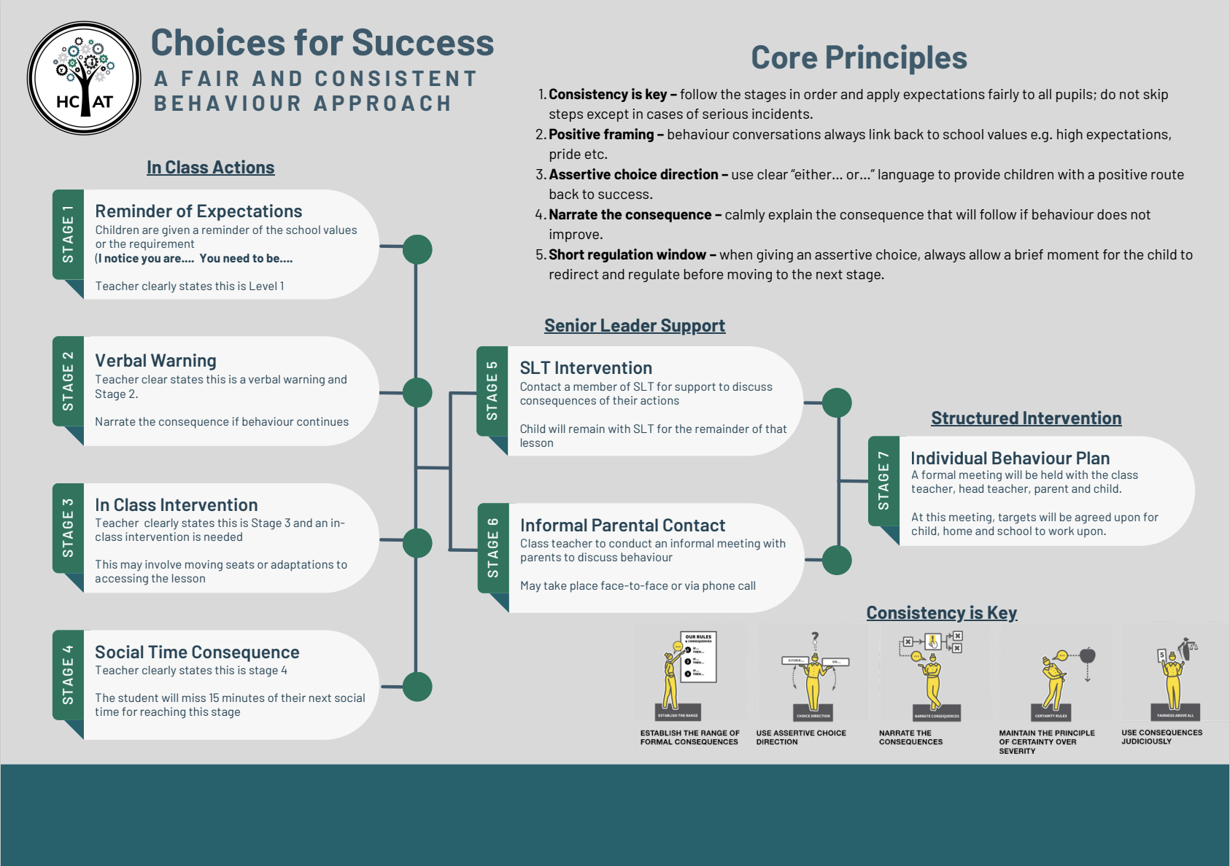

Appendix 3
Stage 1 Letter:

Dear Parent/Carer,

Supporting Your Child's Behaviour and Well-being

During the past month, your child has received 5 or more behaviour incidents recorded on our Arbor system. In line with our Behaviour Policy, we feel it is important to make contact with you at this stage so that we can work together to support your child in making positive improvements.

At The Mill Academy, we are committed to understanding the reasons behind behaviour challenges so that we can address them most effectively. We recognise that all children are individuals with different needs and circumstances and our approach is firmly rooted in providing support first, rather than simply applying sanctions.

When behaviour incidents occur repeatedly, they can affect your child and others in several ways:
- It may prevent them from fully engaging with their learning and reaching their potential
- It can impact on their relationships with peers and staff
- It may affect their sense of belonging and well-being within our school community
- It can disrupt the positive learning environment we strive to create for all children

We want to emphasise that we believe your child is capable of meeting our high expectations and we are committed to helping them achieve this.

Over the next four weeks, we will be carefully monitoring your child's behaviour with a focus on encouraging and recognising positive improvements. This monitoring will help us to track progress and identify what strategies are working well as well as adjust our support approach if needed and celebrate successes with your child.

Your support during this time is vital. We believe that when home and school work together with consistent messages, children make the best progress.

If there are any circumstances at home that you feel may be affecting your child's behaviour in school, please do share this with us so we can take this into account in our support approach.

Please be assured that we have your child's best interests at heart. We are confident that with the right support, encouragement and partnership between home and school, your child will be able to demonstrate the positive behaviour we know they are capable of.

If you have any questions or concerns about this, or if you would like to discuss your child's behaviour further, please contact me directly via the school office.

Thank you for your continued support and partnership.

[Your Name]
Head of School
The Mill Academy

Stage 2 Letter:

Dear Parent/Carer,
Invitation to Internal School Behaviour Panel (ISBP) Meeting
During the four-week monitoring period following the stage 1 letter, we have carefully tracked your child's behaviour incidents and the strategies we have implemented to support them. Unfortunately, despite our efforts and interventions in school, we have not seen the improvement we had hoped for at this stage.
We remain committed to supporting your child and believe that a more structured and coordinated approach, involving closer collaboration between home and school, will help them to make the positive changes needed.
In line with our Behaviour Policy, we are want you to attend an Internal School Behaviour Panel (ISBP) meeting to discuss how we can work together more effectively to support your child's behaviour and well-being. The meeting is scheduled for [insert date] at [insert time]. Those attending will be yourself as parent/carer, your child, [Class Teacher name] as Class Teacher, and myself as Headteacher. If this date or time is not convenient, please contact the school office as soon as possible so we can arrange an alternative.
During this meeting, we will review your child's behaviour over the past four weeks and discuss specific incidents that have occurred. We will take time to listen to your child's views and perspectives, as their voice is important in understanding what is happening. Together, we will work to identify any underlying needs, triggers or circumstances that may be affecting their behaviour.
The main outcome of this meeting will be to create an Individual Behaviour Plan (IBP) with clear, achievable targets that your child can work towards. We will agree on specific strategies and interventions to support your child both at home and in school, establishing clear expectations and timescales for the next review period. Throughout this process, we will discuss how we will record and monitor both positive and negative behaviours going forward, ensuring we can celebrate successes as well as address any concerns.
Please be reassured that this process is designed to provide your child with the additional support they need to succeed. For this approach to be successful, we need your full support and commitment. Your attendance at the ISBP meeting is essential, as is your willingness to work collaboratively with us to create the Individual Behaviour Plan. We ask that you implement agreed strategies consistently at home and maintain regular communication with school about your child's behaviour.
Please confirm your attendance at the ISBP meeting by contacting the school office by [insert date - allow reasonable notice]. If you have any questions before the meeting, or if there is any information you feel would be helpful for us to know in advance, please do not hesitate to contact me.
Yours sincerely,
[Your Name]
Head of School
The Mill Academy

Appendix 4
HCAT Recognition Chart
Behaviour Support Plan Criteria
Behaviour Support Plan Template

Appendix 5
Suspension Reintegration Meeting

Appendix 6
Conducting a Search Record

