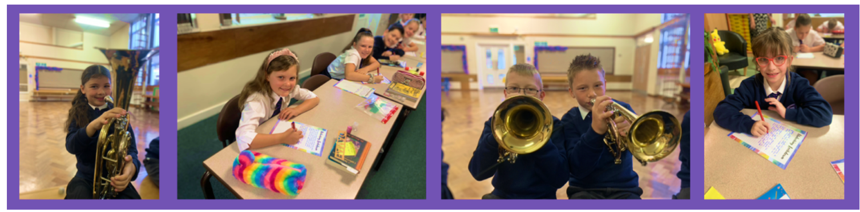


The Mill Academy

Pupil Pledge to our pupils:

As a school, we are dedicated to helping you learn to be kind, confidence, and resilience through the opportunities and experiences we provide.
We will support you to work as a team, think independently, and celebrate your achievements—giving you the tools to aim high and feel proud.

Pledge to Our Pupils:

Inspire, Achieve & Grow
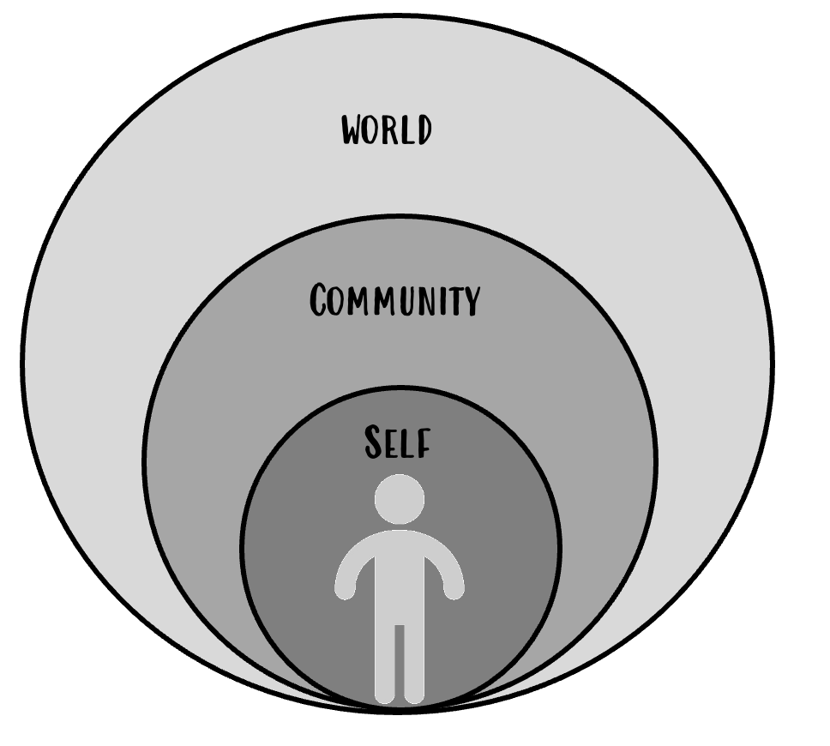
Our pledge has been shaped through listening to our pupils and reflects our shared commitment to their development and success. At The Mill Academy, we strive to inspire every child through enriching experiences, a nurturing environment, and meaningful opportunities that spark curiosity and creativity. We empower pupils to achieve by building confidence, encouraging resilience, and celebrating progress—helping them to reach their full potential.

Through carefully interweaving and developing pupils’ understanding of themselves and others we ensure every child is equipped to thrive and make a meaningful impact on society. Together, we nurture lifelong learners who embody respect, resilience, and a commitment to creating a better future for all. We do this through ensuring pupils have a wealth of opportunities and experiences which are well suited to the school’s context and support them to develop their understanding of:

-Core Values
-Fundamental British Values
-Protected Characteristics
-School Ethos

Through teamwork, independence, and kindness, we support all pupils to grow into respectful, proud, and ambitious individuals ready to thrive in the wider world.


Core Values

We are dedicated to ensuring all pupils have expertly designed and balanced experiences, which support them to develop character traits to enable them to become respectful, hardworking and ambitious individuals.

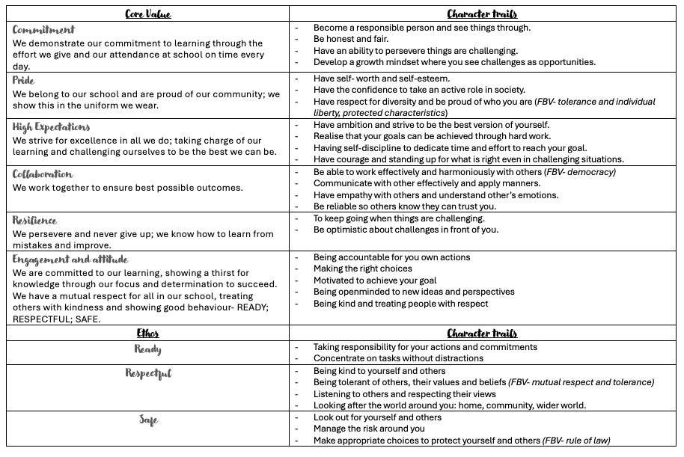

These experiences are designed to build aspiration, tolerance and resilience and broaden pupils’ horizons, opening opportunities throughout their educational journey and beyond. Our pledge has come directly from consultation with our pupils and parents as part of our commitment to ensuring they are provided with high quality experiences and opportunities which build cultural capital and awareness of the wider world.

At Ward Green Primary School, we are committed to nurturing confident, lifelong learners who are proud of their heritage and ready to make a positive contribution to society. To achieve this, we have six key areas of experience that enrich pupil’s life experiences, broaden their horizons and motivate their aspirations. By providing a rich diet of experiences for pupils as part of our school offer, we nurture the whole child and provide opportunities on the journey to adulthood.
The Mill Academy
Inspire, Achieve & Grow

 |  | 
These experiences encourage pupils to build an enduring connection with the world around them, building up essential skills that will stay with them for life. | Educational visits have substantial benefits to the education and development of pupils. For many, they offer opportunities to enrich learning experiences. | Visits that build on the pupil’s understanding of the range of faiths and cultures that compromise our society.  A fundamental British Value to build a mutual respect of other religions and cultures.
 | 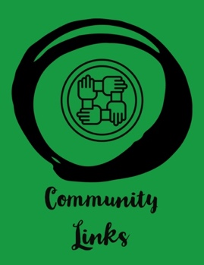 | 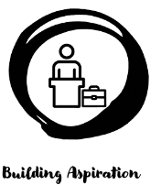
Attending live performances exposes pupils to new crowds and environments. It helps to develop a sense of belonging and build emotional intelligence and appreciation for performance. | Building community and social connections within our locality assists in boosting pupil’s confidence whilst interacting with others who differ from them in age, belief, occupation and other ways. | Opportunities that support pupils to develop their understanding of future prospects and careers enable them to develop ambition and aspiration.


The Mill Academy
Inspire, Achieve & Grow

Early Years Foundation STAGE
Pledge to Our Pupils

LIFETIME EXPERIENCES | CURRICULUM FOCUS
  - Library  - Care home  - Emergency Services |   - Bonfire night  - My local area – local walk  - Trip to Worsborough Mill
PEOPLE & PLACES OF WORSHIP | SPORTS & ARTS PERFORMANCE
  - Church  Diversity- visitors/guest speakers |   - Summer festival  - EYFS Natvity  Art gallery/ town hall museum
COMMUNITY LINKS | BUILDING ASPIRATION
  - Asda  - Litter picking  Library | 

The Mill Academy
Inspire, Achieve & Grow

KEY STAGE 1/YEAR 1
Pledge to Our Pupils

LIFETIME EXPERIENCES | CURRICULUM FOCUS
use of cutlery  Christmas workshop  Balance-a-bility | - Bonfire night  - My local area – local walk  - Trip to Worsborough Mill
PEOPLE & PLACES OF WORSHIP | SPORTS & ARTS PERFORMANCE
- Church  Diversity- visitors/guest speakers | - Sports Day  - KS1 Nativity  Art gallery/ town hall museum
COMMUNITY LINKS | BUILDING ASPIRATION
- Care home
- Asda
- Litter picking
Library

The Mill Academy
Inspire, Achieve & Grow

KEY STAGE 1/YEAR 2
Pledge to Our Pupils

LIFETIME EXPERIENCES | CURRICULUM FOCUS
Primary Enterprise challenge  Local Outdoor walks  School council  Christmas workshop  Summer music festival  Trips and Visits | Craft workshop  Summer fair  Church  Police/fire service visits  Local walks
PEOPLE & PLACES OF WORSHIP | SPORTS & ARTS PERFORMANCE
- Church  Diversity- visitors/guest speakers | - Summer festival  - KS1 Nativity  Art gallery/ town hall museum
COMMUNITY LINKS | BUILDING ASPIRATION
- Asda
- Litter picking
Library

LIFETIME EXPERIENCES | CURRICULUM FOCUS
Primary Enterprise challenge  Local Outdoor walks/woodland walks  School council  Trips and visits | Craft workshop  Summer fair  Church  Police/fire service visits  Local walks
PEOPLE & PLACES OF WORSHIP | SPORTS & ARTS PERFORMANCE
- Church  Diversity- visitors/guest speakers | - Easter performance  - Sporting events  - Sports Competitions.
COMMUNITY LINKS | BUILDING ASPIRATION
- Litter picking
Xxx
xxx

KEY STAGE 2/YEAR 3
Pledge to Our Pupils

The Mill Academy
Inspire, Achieve & Grow

The Mill Academy
Inspire, Achieve & Grow

KEY STAGE 2/YEAR 4
Pledge to Our Pupils

LIFETIME EXPERIENCES | CURRICULUM FOCUS
Safety around school/environment  Seaside  Food technology – baking/cooking  Brass concert  Christmas workshop | Coal mining museum  Coastal visit  History museum trip  Swimming
PEOPLE & PLACES OF WORSHIP | SPORTS & ARTS PERFORMANCE
Visitors in school  Visit places of worship – Buddhist temple  Church visit | Inter school competitions  Class competitions  Music concert at metrodome  The big sing  Use of performance artists within school  Christmas workshop
COMMUNITY LINKS | BUILDING ASPIRATION
Local church
Local walk/litter picking
Mining visits
Local park - recycling

The Mill Academy
Inspire, Achieve & Grow

KEY STAGE 2/YEAR 5
Pledge to Our Pupils

LIFETIME EXPERIENCES | CURRICULUM FOCUS
Junior wardens  Bikeability  School Council  Primary Enterprise challenge  Theatre trip  Christmas workshop | Langsett  Space centre  Art Gallery  Guest speaker
PEOPLE & PLACES OF WORSHIP | SPORTS & ARTS PERFORMANCE
Local church  Mosque  virtual tours  Visitors into school – imam, priest, etc. | The big sing  Concerts  Athletics visits
COMMUNITY LINKS | BUILDING ASPIRATION
Grassroots/Reds in the community
Litter pick
Junior wardens

The Mill Academy
Inspire, Achieve & Grow

KEY STAGE 2/YEAR 6
Pledge to Our Pupils

LIFETIME EXPERIENCES | CURRICULUM FOCUS
Crucial Crew  Theatre- Musical  leading assemblies  Enterprise challenge  Outdoor Adventurous Experience / residential  Christmas workshop | Kelham Island- WWII Visit (Hist)  Residential (pD)  Gallery/Museum (Art)  librarians
PEOPLE & PLACES OF WORSHIP | SPORTS & ARTS PERFORMANCE
Local Church  Remembrance Service  Visits from Local Vicar  synagogue Visit | End of year concert  English Institute of Sport  Summer music festival  Cross Trust Sporting Competitions
COMMUNITY LINKS | BUILDING ASPIRATION
Barnsley Arts Competition
Eco Council
MP Visit & Town Hall- Local Parliament Visit
Cinema trip

